The Four Rules

By the erudite scholar Muhammad ibn ‘Abdul-Wahhāb
(may Allah have mercy upon him)

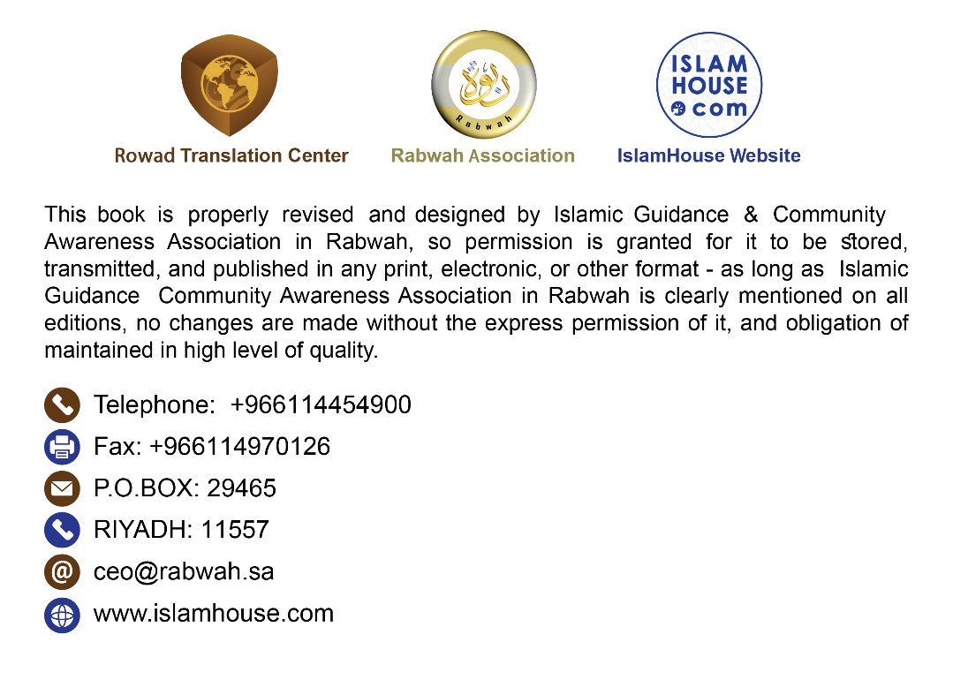

The Four Rules
By the erudite scholar Muhammad ibn ‘Abdul-Wahhāb (may Allah have mercy upon him)
In the Name of Allah, the Most Compassionate, the Most Merciful
I implore Allah Almighty, Lord of the Magnificent Throne, to protect you in this life and in the Hereafter;
to make you blessed wherever you may be; and to make you one of those who are grateful when granted blessings, patient when afflicted, and who ask forgiveness when they sin - for indeed these three things are the key to happiness.
Let me tell you - may Allah guide you to His obedience - that the Hanīfiyyah, the religion of Ibrāhim (Abraham), is to worship Allah alone with sincere devotion as Allah Almighty says: {I have not created the jinn and mankind except to worship Me.} [Surat adh-Dhāriyāt: 56] When you realize that Allah has created you to worship Him, you should also realize that worship cannot be called "worship" unless done with monotheism, just as prayer cannot be valid without ritual purification. So, if worship is marred by polytheism, it gets spoiled just as one’s ritual purification gets spoiled by Hadath (ritual impurity). Knowing that polytheism spoils worship and causes one’s deeds to be worthless and sends one forever to Hellfire makes it your greatest duty to get acquainted with this so that Allah may save you from this trap of associating partners with Allah Almighty, Who says: {Allah does not forgive associating partners with Him, but forgives other than that to whom He wills.} [Surat an-Nisā’: 116] This can be achieved by knowing four rules, which Allah sets out in His Book.

First Rule:
Knowing that the polytheists against whom the Prophet (may Allah’s peace and blessings be upon him) fought did acknowledge that Allah is the Creator and the Disposer of affairs, but this did not bring them into the fold of Islam as proven in the verse that says: {Say, “Who provides for you from the heaven and earth? Or who owns [your] hearing and sight? Who brings forth the living from the dead and the dead from the living? Who controls all things?” They will say, “Allah.” Say, “Do you not then fear Him?”} [Surat Yūnus: 31]

Second Rule:
They said: We invoked them and turned to them for the sole purpose of nearness and intercession. The claim about nearness occurs in the verse that says: {As for those who take others as guardians besides Him, [saying], “We only worship them so that they may bring us closer to Allah.” Allah will judge between them concerning that over which they differ. Allah does not guide anyone who is a liar and persistent disbeliever.} [Surat az-Zumar: 3] The claim about intercession is mentioned in the verse that says: {They worship besides Allah those who can neither harm nor benefit them, saying, “These are our intercessors with Allah.”} [Surat Yūnus: 18]
Intercession is of two types: negated intercession and established intercession.
The negated intercession is the one sought from other than Allah in things which none but Allah is capable of doing as proven in the verse that says: {O you who believe, spend from what We have provided for you before there comes a day when there will be no trading, friendship, or intercession. It is the disbelievers who are the wrongdoers.} [Surat al-Baqarah: 254]
The established intercession is the one sought from Allah. The intercessor is honored by intercession, and the one for whom it is sought has been granted permission by Allah, Who is pleased with his words and deeds as Allah Almighty says: {Who is there that can intercede with Him except with His permission?} [Surat al-Baqarah: 255]

Third Rule:
The Prophet (may Allah’s peace and blessings be upon him) emerged among people with different forms of worship. Some worshiped the angels, and others worshiped the prophets and pious people, while some worshiped the trees and stones, and there were worshipers of the sun and the moon. The Prophet (may Allah’s peace and blessings be upon him) fought them all without discrimination, as revealed in the verse that says: {Fight them until there is no more persecution and the religion is entirely for Allah.} [Surat al-Anfāl: 39] The worship of the sun and the moon occurs in the verse that says: {Among His signs are the night and the day, the sun and the moon. Do not prostrate to the sun or to the moon, but prostrate to Allah Who created them, if you truly worship Him.} [Surat Fussilat: 37] The worship of angels is mentioned in the verse that says: {Nor would he order you to take angels and prophets as lords...} [Surat Āl ‘Imrān: 80] The worship of prophets is mentioned in the verse that says: {When Allah will say, “O Jesus, son of Mary, did you tell people, “Take me and my mother as gods besides Allah?” He wills say, “Glory be to You! It is not for me to say what I have no right. Had I said so, You would have surely known it. You know what is within myself, whereas I do not know what is within Yourself. Indeed, You are the All-Knower of all unseen.”} [Surat al-Mā’idah: 116]
The worship of pious people occurs in the verse that says: {Those whom they call upon seek means of nearness to their Lord, each trying to become closer, hoping for His Mercy and fearing His punishment...} [Surat al-Isrā’: 57] And the worship of trees and stones is mentioned in the verse that says: {Have you [O disbelievers] thought about [the idols of] al-Lāt and al-‘Uzzā, and Manāt, the third one as well?} [Surat an-Najm: 19-20]
It is also mentioned in a Hadīth in which Abu Wāqid al-Laythi (may Allah be pleased with him) reported: “We set out along with the Messenger of Allah (may Allah’s peace and blessings be upon him) heading to Hunayn, as we were still new in Islam. The polytheists had a tree to which they were devoted and which they called "Dhāt Anwāt" and upon it they hung their weapons (for blessing). As we passed by a tree, we said: ‘O Messenger of Allah, take for us a Dhāt Anwāt (tree) as they have a Dhāt Anwāt...’”

Fourth Rule:
The polytheists in our time are worse in terms of polytheism than the earlier polytheists, for the early ones would associate partners with Allah at times of opulence and be sincerely devoted to Allah during hardships, but the late ones associate partners with Allah constantly at both good and hard times. This is revealed in the verse that says: {When they board a ship, they supplicate Allah, devoting their faith sincerely to Him. But as soon as He rescues them to the land, they associate partners with Him.} [Surat al-‘Ankabūt: 65]
Allah knows best, and may Allah’s peace and blessings be upon our Prophet Muhammad and his family and Companions.

The Four Rules 3
First Rule: 4
Second Rule: 4
Third Rule: 5
Fourth Rule: 6

