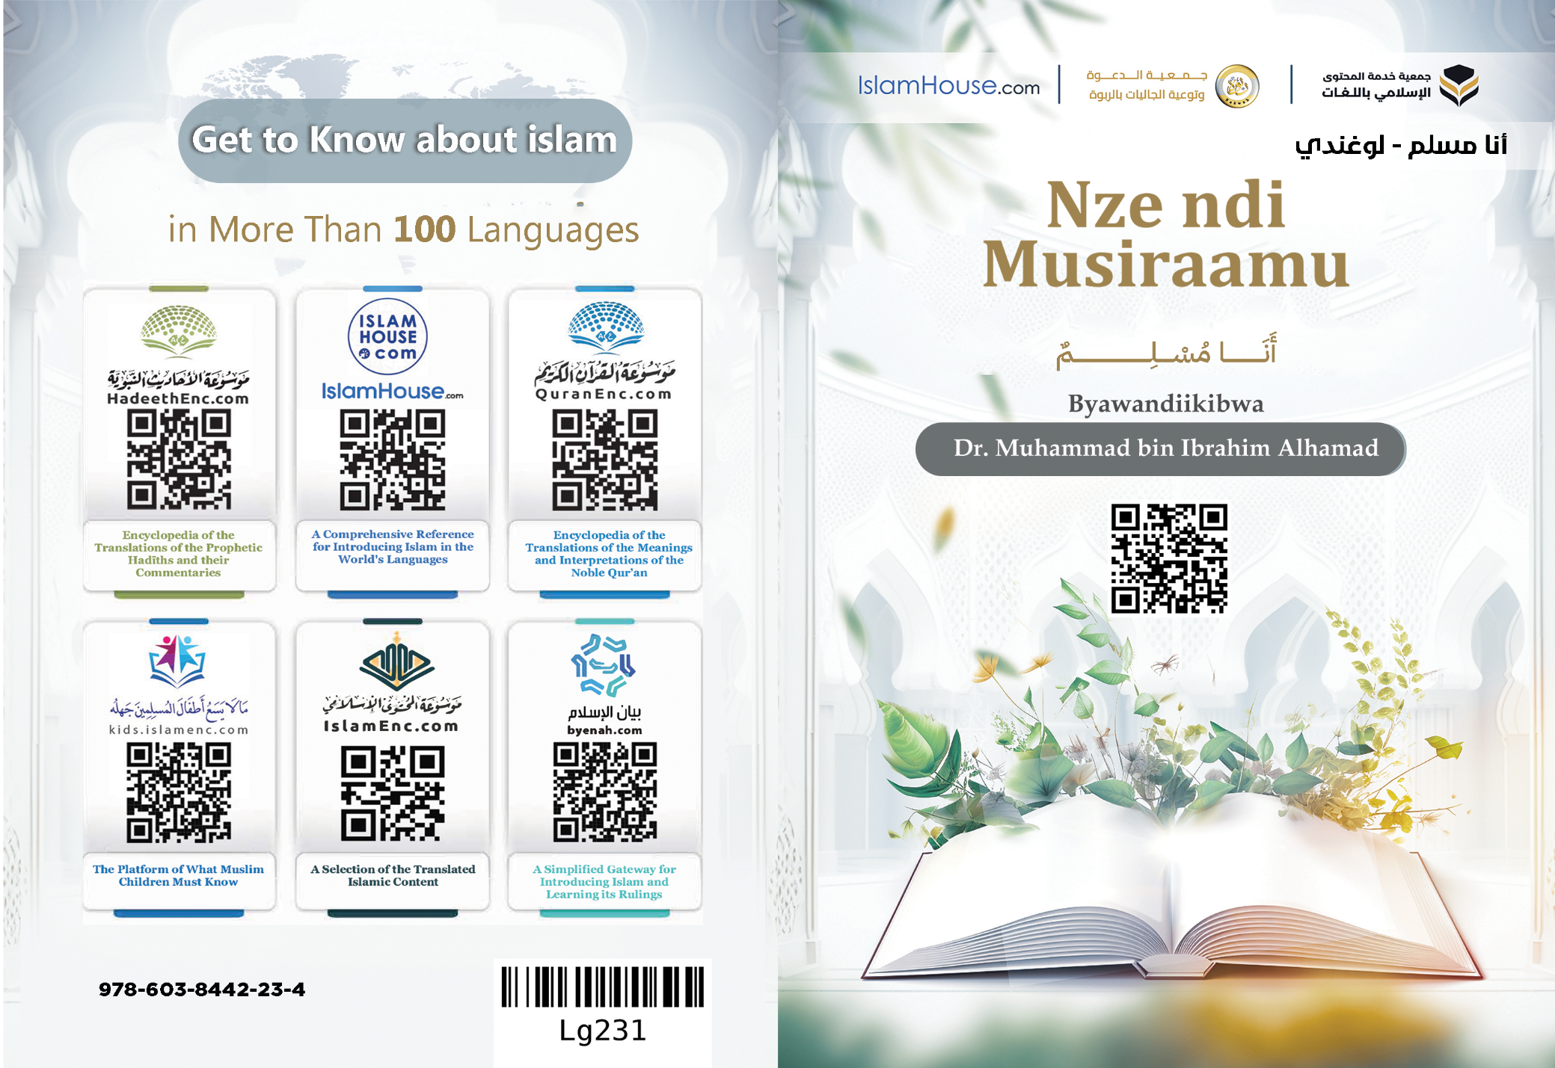
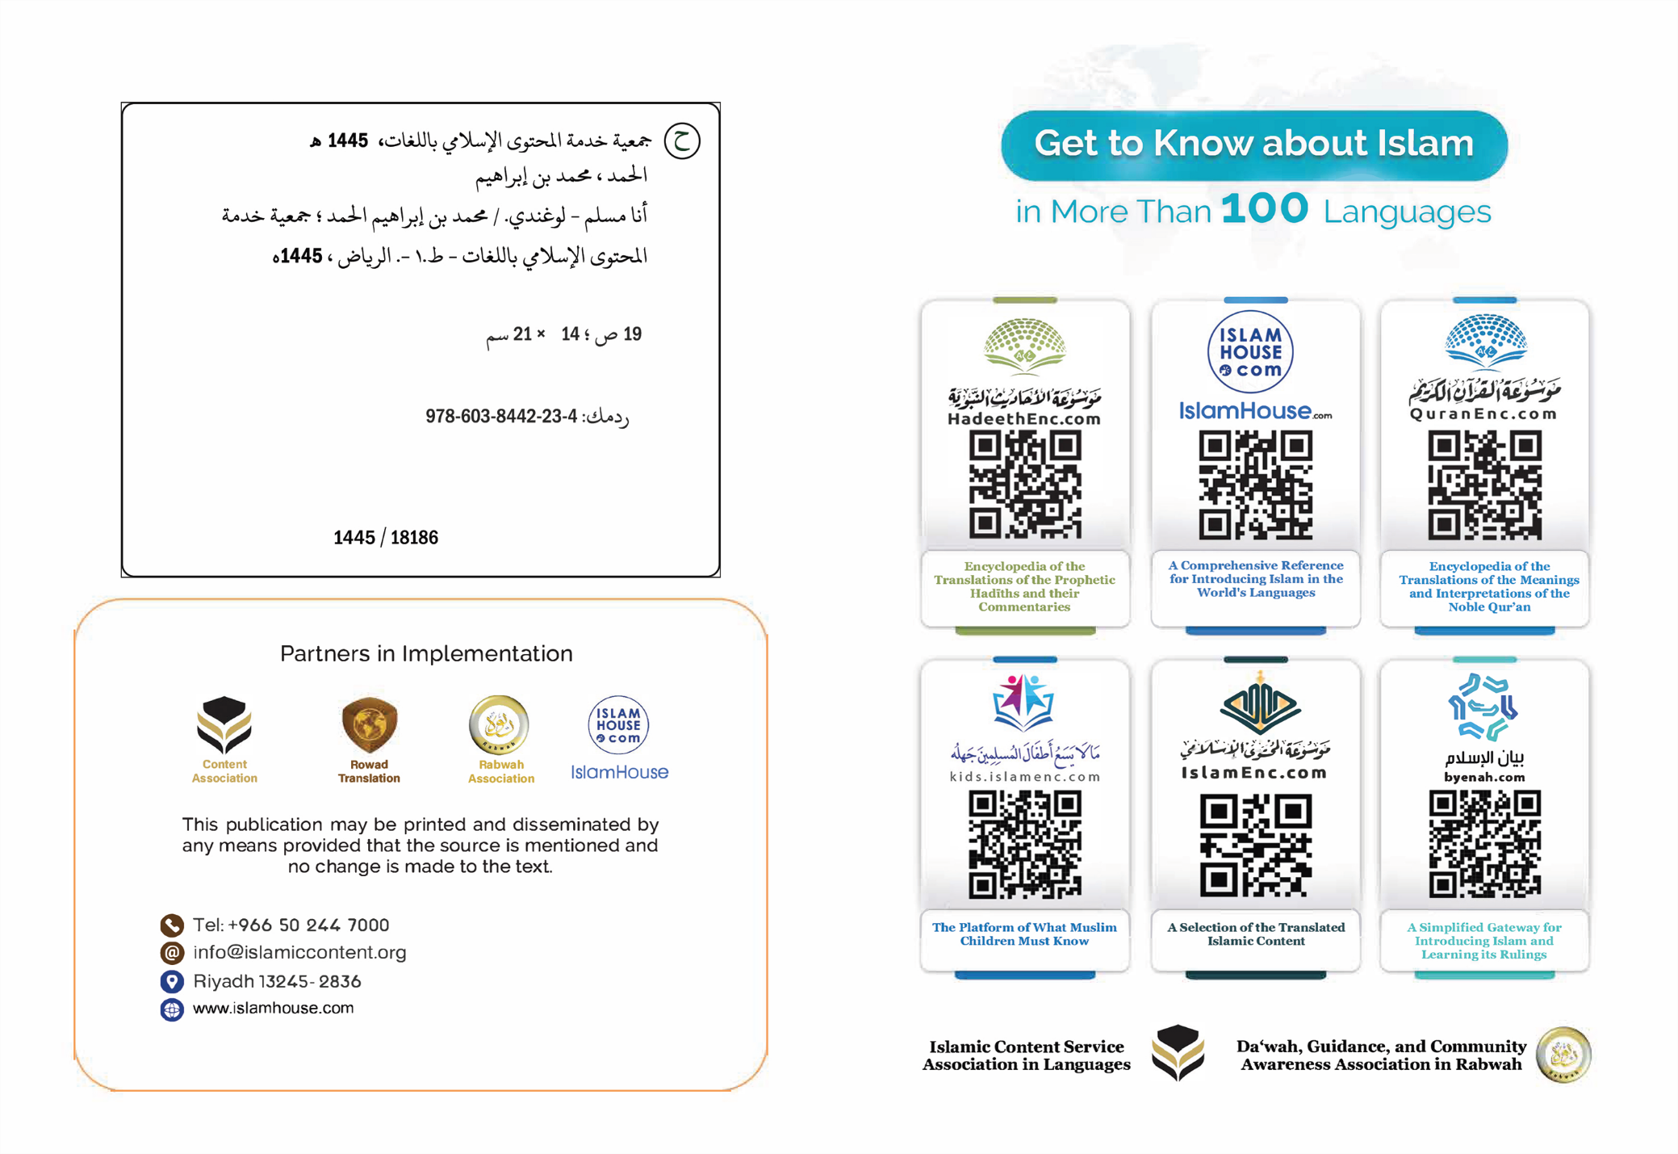

Nze ndi Musiraamu

Byawandiikibwa
Dr. Muhammad bin Ibrahim Alhamad

Nze ndi Musiraamu
Nze ndi Musiraamu, ekyonno kitegeeza nti mazima eddiini yange bwe busiraamu, era Obusiraamu kigambo kikulu, kigulumizibwa, kyasikirwanga ba nnabbi -emirembe gibeere ku bbo- okuva ku yasooka ppaka ku yaseembayo; era ekigambo kino kirina amakulu aga waggulu n'ennono enkulu; era kyo kitegeeza okwewaayo, n'okugoberera, n'obuwulize eri Omutonzi, era kitegeeza emirembe, n'okuwona, n'essanyu, n'obutebenkevu, n'obukkakkamu eri ssekinnoomu n'ekibinja. era kyekyo lwaki ebigambo mirembe ne Busiraamu by'ebimu ku bisinga okulabikira mu ssemateeka w'obusiraamu; nabwekityo emirembe linnya mu mannya ga Allah, era ekiramuso ky'abasiraamu wakati waabwe ye "Salaam" [amakulu: emirembe], era n'ekiramuso ky'abantu boomu jjana "Salaam", era omusiraamu owa nnamaddala y'oyo abasiraamu abasigadde gwebawona ebikyamu ebiva ku lulimi lwe n'emikono gye. kale Obusiraamu ddiini ya bulungi bwa bantu bonna; era yyo ebabuna, era ly'ekkubo ly'okwesiima kwabwe mu nsi ne ku nkomerero; era ky'eva yajja nga efundikira, nga emalayo, nga ngazi, nga nnambulukufu, nga nzigule eri buli omu, teyawula ndyo ku ndala, yadde langi ku langi endala, wabula etunuulira abantu olutunuulira lumu, era omuntu mu busiraamu talina nkizo okuggyako olw'ekigero kye (ky'aba atuuseeko) mu kwekwata ku njigiriza zaabwo. era y'ensonga lwaki emyoyo gyonna emitereevu gibukkiriza; kubanga bukwatagana n'obutonde; kale buli muntu azaalibwa nga ali ku bubumbwa obw'obulungi, n'obwenkanya, n'eddembe, nga ayagala Omulezi we, nga akakasa nti mazima yye ye Musinzibwa agwanidde okusinzibwa yekka awatali kirala; era tewali aseeseetuka kuva ku bubumbwa buno okujjako nga waliwo ekibukyusizza, era eddiini eno Omutonzi w'abantu yeeyagisiimira abantu, era Omulezi waabwe, era Omusinzibwa waabwe.
era eddiini yange Busiraamu enjigiriza nti nja kuwangaala ku nsi kuno, ate oluvannyuma lw'okufa kwange nja kujjulukuka okugenda mu nnyumba endala, era nga y'ennyumba ey'olubeerera era y'eyokuba obuddo bw'abantu, nga bwa kuba mu jjana oba mu muliro.
era eddiini yange Busiraamu erina ebiragiro by'endagira era erina ebiziyizibwa by'enziyiza; era bwemba ntuukirizza ebiragiro ebyo, era nenneewala ebiziyizibwa ebyo, neesiima ku nsi ne ku nkomerero, ate bwemba mbisuuliridde, wabaawo okufaafaaganirwa ku nsi ne ku nkomerero okw'ekigero ky'okusuulirira kwange n'obukendeevu bwange. era ekisinga obukulu Obusiraamu kyebwandagira; kwawula Allah. nabwekityo nze mpa obujulizi, era nkakasa olukakasa olunywevu nti mazima Allah ye Mutonzi wange, era ye Musinzibwa wange; kale ssisinza okujjako Allah; olw'okumwagala, n'olwokutya ebibonerezo bye, n'olwokusuubira empeera ye, n'olwokumwesiga, era okwawula Allah okwo kweyolekera mu kukakasa obwomu bwa Allah, n'okukakasa obubaka eri nabbi we Muhammad okusaasira n’emirembe bibeere ku yye; era Muhammad y'owenkomerero mu ba nnabbi; Allah yamutuma nga kya kusaasira eri ebitonde, era n'afundikira naye obwa nnabbi n'obubaka; era tewali nnabbi luvannyuma lwe, era yajja n'eddiini ebuna etuukana na buli mulembe, n'ekifo, n'ekibiina [ky'abantu].
era eddiini yange endagira ekiragiro ekikakafu; okukkiririza mu ba malayika, n'ababaka bonna, era nga ababakulembeddemu ye Nuuhu ne Ibrahim ne Musa ne Isa ne Muhammad - emirembe gibeere ku bbo - .
era endagira okukkiririza mu bitabo ebyava mu ggulu ebyo ebyassibwa ku babaka, era [n'endagira] okugoberera ekyasembayo mu byo, era ekyenkomerero ku byo, era ekibisinga obukulu, era nga nakyo ye (Kkulaani ey’ekitiibwa).
era eddiini yange endagira okukkiririza mu lunaku lw’enkomerero; olwo abantu mwe bagenda okusasulirwa emirimu gyabwe, era endagira okukkiririza mu kugera (kwa Allah), n'okusiima ekyo ekiba ekyange mu buno obulamu mu birungi n'ebibi, era n'okufuba okwekwata ku nsonga ezituusa ku kuwona. era okukkiririza mu kugera (kwa Allah) kumpa eddembe n'obutebenkevu, n'obugumiikiriza, n'okulekayo okwekubagiza ku kinsubye; kubanga mazima nze manyi okumanya okwa nnamaddala nti mazima ekintuukako tekyali kya kunsuba, era n'ekinsuba tekyali kya kuntuukako; kale buli kimu kigere era kiwandiike okuva eri Allah, era tewali kinkakatako okujjako okuteekawo amakubo (agantuusa), n'okusiima kyonna ekiba kibadde oluvannyuma lw'ekyo.
era Obusiraamu bundagira ebyo ebitukuza omwoyo gwange mu mirimu emirungi, n'empisa ensukkulumu ezisiimisa Omulezi wange, era neziyonja omwoyo gwange, era nezisanyusa omutima gwange, era nezanjuluza ekifuba kyange, era nezaakaayakanya ekkubo lyange, era nezinfuula ekitundu eky'omugaso mu bantu wempangalira.
era ogusinga obukulu mu mirimu egyo: kwawula Allah, n'okuyimirizaawo esswala ettaano emisana n'ekiro, n'okutoola zzaka y'ebyobugagga, n'okusiibayo omwezi (gumu) mu mwaka, era nga nagwo gw'omwezi gwa lamanzaani, n'okulamaga ku nnyumba ey'emizizo e Makka eri oyo aba asobodde okukola hijja.
era mu bimu ku bisinga obukulu eddiini yange byeyandagirira, mwebyo ebyanjuluza ekifuba; kwekuyitiriza okusoma Kkulaani; era nga yyo bigambo bya Allah, era nga y'emboozi esinga okuba ey'amazima, era nga by'ebigambo ebisinga okuba ebirungi era ebikulu, era eby'ekitiibwa ebijjuddemu ebikwata ku baakulembera n'abavannyuma; kale okujisoma oba okujiwuliriza kiyingiza obutebenkevu n'eddembe n'essanyu mu mutima, nebwaba nga omusomi oba omuwuliriza tamanyi luwarabu oba yadde ssi musiraamu. era mu bimu ku bisinga okwanjuluza ekifuba; kwekuyitiriza okusaba Allah, n'okudda gyali, n'okumusaba buli katono konna nabuli kinene; kuba yye Allah ayanukula oyo amusabye era n'amwawulira okusinza.
era mu bisinga okwanjuluza ekifuba kwekuyitiriza okwogera ku Allah - ow'amaanyi era ow'ekitiibwa -.
era nnabbi wange - okusaasira n’emirembe bibeere ku yye - yandagirira butya bwenzijukira n'okwogera ku Allah, era n'anjigiriza enzijukira n'enjogera ku Allah ezisinga, era muzo mwe muli: ebigambo ebina ebisinga obulungi oluvannyuma lwa Kkulaani, era nga nabyo: (Subhaana Llaah, ne Alhamdu liLlaah, ne Laa ilaaha illa Llaah, ne Allahu akbar).
era nabwekityo (AstaghfiruLlah, ne Laa hawla wa laa quwwata illaa biLlaah).
kale ebigambo bino birina enjawulo eyeewunyisa mu kwanjulukuka kw'ekifuba, n'okukka kw'obutebenkevu mu mutima.
era Obusiraamu bundagira okuba ow'ekitiibwa ekya waggulu, mbeere wala n'ebikkakkanya obuntu bwange n'ekitiibwa kyange. era nkozese amagezi gange n'ebiyungo byange mw'ebyo ebyabitondesa mu mirimu egigasa mu ddiini yange ne mubulamu bwange obw'ensi.
era Obusiraamu bundagira okuba n'ekisa, n'empisa ennungi, n'okukolagana obulungi [n'abantu], n'okulongoosa eri ebitonde nga bwemba nsobodde mu bigambo n'ebikolwa.
era mu bivunaanwa ebisinga obukulu eri ebitonde byennalagirwa; eddembe ly'abazadde ababiri (okubayisa obulunji). Eddiini yange endagira okubagondera, n'okubaagaliza obulungi, n'okufaayo ennyo okubasanyusa, n'okubaweereza; naddala nga bakuliridde; y'ensonga lwaki olaba nga maama ne taata mu bitundu by'abasiraamu babeere ku ddaala lya waggulu mu kugulumizibwa n'okuweebwa ekitiibwa, n'okuweerezebwa okuva eri abaana baabwe, ate buli bazadde ababiri bwebakula mu myaka, oba nebafunamu ku bulwadde oba okulemererwa, okuyisibwa kwabwe obulungi okuva eri abaana kweyongera. era eddiini yange yanjigiriza nti mazima omukyala alina ekitiibwa kya waggulu, n'eddembe ly'amaanyi; anti abakyala mu busiraamu bali nga abasajja, era asinga obulungi mu bantu bonna; y'oyo asinga obulungi eri bakyala be; Omukyala omusiraamu mu buto bwe; ddembe lye okuyonsebwa, n'okulabirirwa, n'okukuzibwa obulungi, ate nga mu kiseera ekyo abeera atebenkeza amaaso, era nga kibala kya mutima eri bazadde be ne bannyina. ate bw'akula n'agulumizibwa era aweebwa ekitiibwa, abubirwa amulinako obuvunaanyizibwa, era amulabirira mu mbeera zonna, kale tasobola kusiima mikono mikyamu kumutuukako, yadde okunyizibwa n'ennimi, yadde okukwenyakwenyezebwa n'amaaso. ate bw'afumbirwa, ekyo kibeerawo na kigambo kya Allah, awamu n'endagaano ye ey'amaanyi ennywevu ddala; bw'atyo n'abeera mu nnyumba ya bba n'omuliraano ogusinga okuba ogw'ekitiibwa, era kikakata ku bbaawe okumuwa ekitiibwa, n'okulongoosa gyali, n'obutamunakuwaza.
ate bwabeera maama, okumuyisa obulungi kwekuddirira ebivunaanwa bya Allah - owa waggulu -, era okumujeemera n'okumuyisa obubi; bibeera wamu n'okugatta ku Allah, n'okwonoona mu nsi.
ate bwabeera mwannyina, abeera y'oyo eyalagirwa omusiraamu okuyungagana (oluganda) naye, n'okumugulumiza, n'okumububira, ate bwabeera maama omuto, abeera ali mu ddaala lya maama mu kuyisibwa obulungi n'okuyungagana (oluganda).
ate bwabeera jajja, oba nga mukulu mu myaka; omuwendo gwe gweyongera eri abaana be n'abazzukulu n'aboluganda bonna; kumpi tammibwa ky'asaba kyonna, yadde ekirowoozo kye okujungululwa.
ate bwabeera wa luganda lwa wala n'omuntu nga oluganda lwe terumusembeza, yadde omuliraano; abeera n'eddembe ly'obusiraamu ery'awamu ng'obutamukosa, n'okukkakkanya amaaso n'ebiringa ebyo.
era ebitundu (omuwangaalirwa e) by'abasiraamu bikyakuuma eddembe eryo mu bwennyini bw'okulikuuma, bikyawa omukyala ekitiibwa n'eddaala, byatabeera nabyo mu mu bitundu by'abatali basiraamu.
ate era omukyala mu busiraamu alina eddembe ly'okuba n'obwannannyini (ku bintu), n'okupangisa, n'okugula, n'okutunda, n'endagaano ezisigadde, era alina eddembe ly'okusoma, n'okusomesa, n'okukola, kasita bitayawukana na ddiini ye, gamba nno ate, waliwo n'okumanya okukakata ku buli muntu, ng'akuleka afuna omusango ssi nsonga musajja oba mukyala.
sso era alina buli ddembe abasajja lyebalina, okuggyako ebyo ebimweyawulidde nga abasajja tebabirina, oba ebyo ebibeeyawulidde (abasajja) nga yye tabirina, mu eddembe n'amateeka ago agasaanidde buli omu ku bbo, nga okunyonyola bwe kuli ku byo mu bifo byakwo.
era eddiini yange endagira okwagala baganda bange, ne bannyinaze, ne ba taata bange abato, ne ba ssenga bange, ne ba kojja bange, ne ba maama bange abato, n'aboluganda lwange bonna, era endagira okuwa eddembe mukyala wange, n'abaana bange, ne baliraanwa bange.
era eddiini yange endagira okumanya, era enkubiriza buli kisitula okutegeera kwange, n'empisa zange, n'endowooza yange.
era endagira okuba n'ensonyi, n'obukwatampola, n'obugabi, n'obuvumu, n'okutegeera, n'obukkakkamu, n'obugumiikiriza, n'obwesigwa, n'obwetowaze, n'ensa, n'obwerufu, n'okutuukiriza, n'okwagaliza abantu obulungi, n'okulafuubana okunoonya ebyenfuna (liziki), n'okusaasira abateesobola, n'okulambula abalwadde, n'okutuukiriza ebisuubizo, n'okwogera obulungi, n'okusisinkana abantu n'akamwenyumwenyu, n'okufaayo okubasanyusa ne kyensobodde.
era n'ekyennyume ky'ebyo, enneewaza obutamanya, era n'eŋŋaana obukaafiiri [okuwakanya obusiraamu], n'obutakkiririza mu Katonda, n'obujeemu, n'ebyobukaba, n'obwenzi, n'ebisiyaga, n'okwekuluntaza (amalala), n'ensaalwa, n'enge, n'okulowooleza (abantu) obubi, n'okusuubira ebibi, n'okunakuwala, n'okulimba, n'okuggwamu essuubi, n'obukodo, n'obugayaavu, n'obutiitiizi, n'obutaba na mulimu, n'okunyiiga, n'okwewussa, n'okwesiruwaza, n'okukosa abantu, n'okwogera ennyo ebitaliimu mugaso, n'okusaasaanya ebyama, n'obukumpanya, n'okwawukana ku ndagaano, n'okuyisa obubi abazadde, n'okukutula oluganda, n'okulekerera abaana, n'okunyiiza baliraanwa n'ebitonde okutwaliza awamu.
era Obusiraamu bunziyiza okunywa ebitamiiza, n'okukozesa ebikyusa amagezi, n'okukuba zzaala mu ssente [n'ebyobugagga], n'obubbi, n'obulyake, n'obukumpanya, n'okukanga abantu, n'okubakettereza, n'okulondoola obumogo bwabwe.
era eddiini yange Busiraamu ekuuma eby'obugagga, era mwekyo mulimu okubunyisa emirembe n'obutebenkevu; era kyekyo lwaki yakubiriza obwesigwa, era n'etendereza ba nnyini bwo, era n'ebasuubiza okuwangaala obulungi, n'okuyingira e jjana ku nkomerero, era n'eziyiza obubbi, era n'eraganyisa ababukola okubonerezebwa ku nsi ne ku nkomerero.
era eddiini yange ekuuma emyoyo [obulamu], era kyekyo lwaki yaziyiza okutta omwoyo mu butali butuufu, n'obulumbaganyi eri abalala mu ngeri zonna ez'obulumbaganyi ne bwekiba mu bigambo.
gamba ate, yaziyiza n'omuntu okutuusa ku mwoyo gwe obulumbaganyi; era n'etakkiriza muntu kwonoona magezi ge, oba okusaanyaawo obulamu bwe [obw'omubiri], oba okwetta.
era eddiini yange Busiraamu ewa obweyamu ku ddembe [eryenjawulo], era n'eriluŋŋamya; kale omuntu mu busiraamu alina eddembe mu kulowooza kwe, ne mu kutunda kwe, ne mu kugula kwe, ne mu kusuubula kwe, ne mu ntambula ze, era alina eddembe ly'okweyagala n'ebirungi by'obulamu mu by'okulya, oba eby'okunywa, oba ebyambalo, oba ebiwulirizibwa ebbanga ly'amala nga takoze bitakkirizibwa ebimuviiramu yye oba abalala okukosebwa.
era eddiini yange eruŋŋamya eddembe [ery'enjawulo]; kale tekkiriza muntu kulumbagana mulala, yadde omuntu okwettanira eby'obwagazi bye ebitakkirizibwa; ebyo ebimalawo ssente ze, n'okwesiima kwe, n'obuntu bwe.
era bwoba otunuulidde abo abaalekera emyoyo gyabwe eddembe mu buli kimu, nebagiwa buli kyegyagala mu by'obwagazi nga tebakomekeddwa kuziyiza kwonna nga okw'eddiini, oba amagezi - ojja kulaba nti mazima bbo bawangalira mu bisirikko by'ennaku n'akanyigo ebisinga okuba ebya wansi, era ojja kulaba abamu ku bbo nga baagala okwetta; olw'okwagala okuva mu kweraliikirira.
era eddiini yange enjigiriza empisa ezisinga obusukkulumu mu kulya, n'okunywa, n'okwebaka, n'okwogera n'abantu.
era eddiini yange enjigiriza eggonjebwa mu kutunda n'okugula, ne mu kusaba abalala eddembe (lyange). era enjigiriza obukwatampola eri benjawukanya nabo eddiini; nga ssi balyazaamanya, era ssi bakosa, wabula mbayise bulungi, era mbaagalize obulungi okubatuukako. era ebyafaayo by'abasiraamu bibajulirako obukwatampola ne be baawukana nabo, obukwatampola obutabeerangako mu kibinja [ky'abantu] kitali bbo; nazima abasiraamu baawangaala n'ebibinja eby'amadiini ag'enjawulo, era ne biyingira mu bufuzi bw'abasiraamu; era abasiraamu baabeeranga - nabo bonna - mu nkolagana esinga obulungi wakati w'abantu. okutwaliza awamu Obusiraamu bwanjigiriza mu mpisa ezoomunda, n'enkolagana ennungi, n'empisa ennungi, ebyo ebirongoosa okuwangala kwange n'okujjuza essanyu lyange, era nebuŋŋaana buli kikalubya obulamu bwange, na buli kikosa ekifaananyi kya awawangaalirwa, oba omwoyo, oba amagezi, oba eby'obugagga (emmaali), oba ekitiibwa, oba omubiri. era okwekwata kwange ku njigiriza zino gyekukoma; n'essanyu lyange gyerikoma okweyongera, era okuzisuulirira kwange gyekukoma n'obukendeevu mu zimu kuzo, okwesiima kwange kukendeera okusinziira ku kigero kyenkendeezezza mu njigiriza ezo.
ate ebyo ebikulembedde tebitegeeza nti ndi mukuume ssisobya, era ssirina bukendeevu; yyo eddiini yange erondoola obutonde bwange obw'obuntu, n'obunafu bwange mu biseera ebimu, kale mbeera n'ensobi, n'obukendeevu, n'okulagaya; era kyekyo lwaki naggulirwawo omulyango gw'okwenenya, n'okusaba okusonyiyibwa, n'okudda eri Allah; era okwenenya kusangula obuufu bw'obukendeevu bwange, era ne kusitula ekifo kyange mu maaso g'Omulezi wange.
era enjigiriza z'eddiini y'Obusiraamu zonna, mu nzikiriza, n'empisa, n'ennono, n'enkolagana; ensibuko yaazo Kkulaani ey'ekitiibwa, n'Enkola [ya Nnabbi okusaasira n’emirembe bibeere ku yye] entukuvu.
n'ekisembayo ŋamba nga nkakasa: ssinga omuntu yenna mu kifo ky'ensi kyonna atuuka ku bwennyini bw'eddiini busiraamu n'eriiso ery'amazima n'okwetengerera; tasigala na kyakukola okujjako okugiyingira, naye ekizibu nti mazima eddiini y'Obusiraamu yabijjisibwa ebigambo eby'obulimba, oba ebikolwa by'abamu ku bagyerimbikamu mu batagigoberera.
era ssinga omuntu atunuulira obwennyini bwayo nga bweri, oba (n'atunuulira) embeera zaaba nyini yo abagiyimirizaawo mu butuufu; tayinza kusikattira mu kugikkiriza, n'okugiyingira, era kijja kumweyolekera nti mazima Obusiraamu bukoowoola okudda eri kusanyusa bantu, n'okunnyikiza emirembe n'obutebenkevu, n'okusaasaanya obwenkanya n'okulongoosa. wabula bbyo ebikyamu by'abeerimbika mu busiraamu - [ssi nsonga] bitono oba bingi - , tekikkirizibwa mu mbeera yonna kutwalibwa nti bya ddiini, oba okubijjisibwa nabyo, wabula yyo eri wala nabyo, era ebiva mu nsobi bidda ku basobezza bennyini; kubanga Obusiraamu tebubibalagira ngako; wabula bwabagaana era nebubeekesa obutakyama kuva ku bwebyajja nabyo. Nate era mazima ddala obwenkanya butegeeza kutunuulira mbeera y'abayimirizaawo eddiini mu butuufu bw'okugiyimirizaawo, era abo abateeka mu nkola ebiragiro byayo n'amateeka gaayo ku bbo bennyini ne ku balala; kubanga mazima ekyo kijjuza emitima okugulumiza n'okuwa ekitiibwa eddiini eno ne bannyini yo; kale Obusiraamu tebwalekayo katono yadde akanene mu kuluŋŋamya n'okugunjula okuggyako nga bwakakubiriza, era tebwalekayo mpisa mbi yadde bwononefu okujjako nga bwabyekesa, era ne buziba ekkubo lyabyo.
era y'ensonga lwaki ababugulumiza, n'abayimirizaawo enjigiriza zaabwo beebasinga okwesiima mu bantu, era beebali mu ddaala erisinga okuba erya waggulu mu mpisa ez'omwoyo, n'okugulerera ku neeyisa ennungi, n'empisa ensukkulumu, bajulirwa kw'ekyo ow'okumpi n'owe wala, n'akkaanya nabo n'ayawukana nabo.
wabula okutunuulira obutunuulizi embeera y'abasiraamu abalagaya mu ddiini yaabwe, abaawukanye ku kkubo lyayo eggolokofu - ekyo tebuba bwenkanya yadde, wabula buba bulyazaamanya bwennyini.
n'ekisembayo kuno kukoowoola buli yenna atali musiraamu, afeeyo okumanya Obusiraamu, era abuyingire.
era yenna ayagala okuyingira mu busiraamu talina kimwetaagisa okuggyako okukakasa nti mazima tewali kisinzibwa mu butuufu okuggyako Allah era nti mazima Muhammad mubaka wa Allah, era ayige mu ddiini ebyo by'anaayimirizaawo nabyo Allah byeyamulaalikako, ate buli bw'ayongera okuyiga n'okukola (ebituufu), okwesiima kwe kweyongera, era eddaala lye neririnnya eri Omulezi we.

*****

bigambo ebyawandiikibwa okunnyonnyola Obusiraamu.

