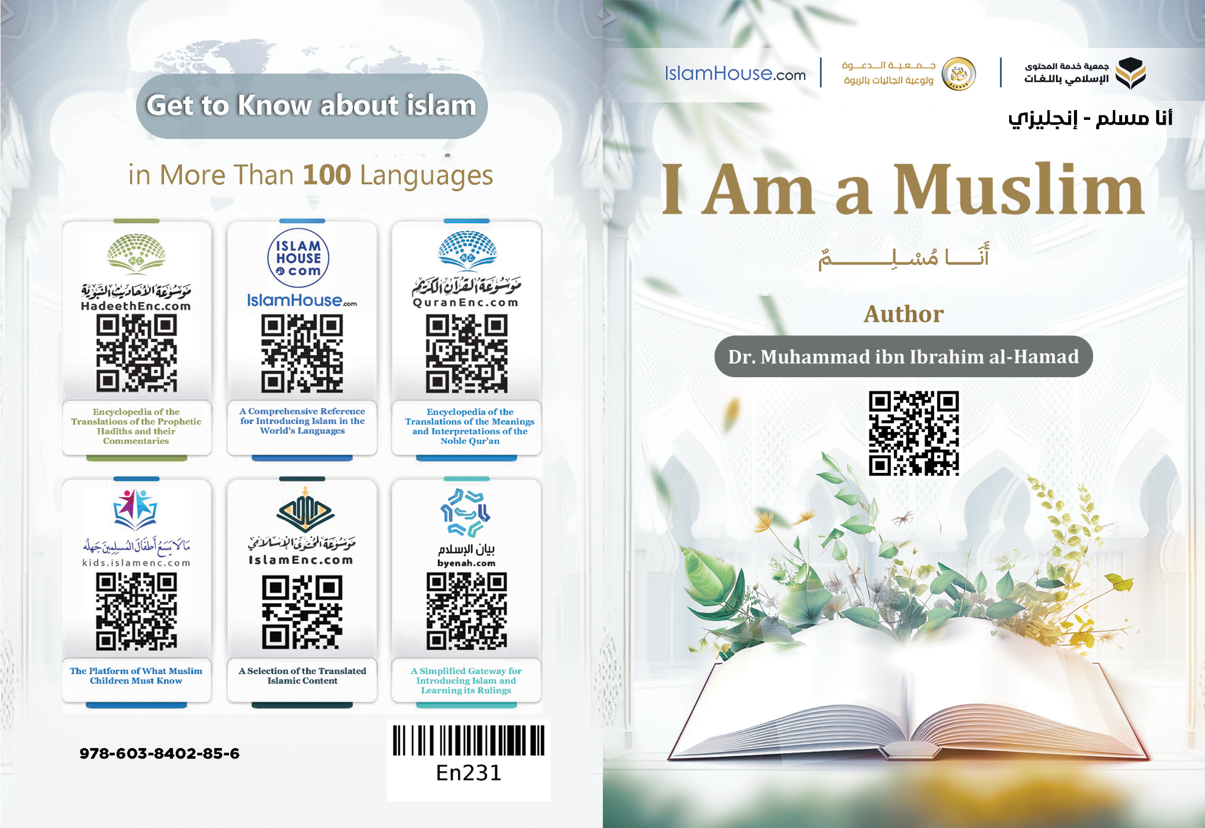
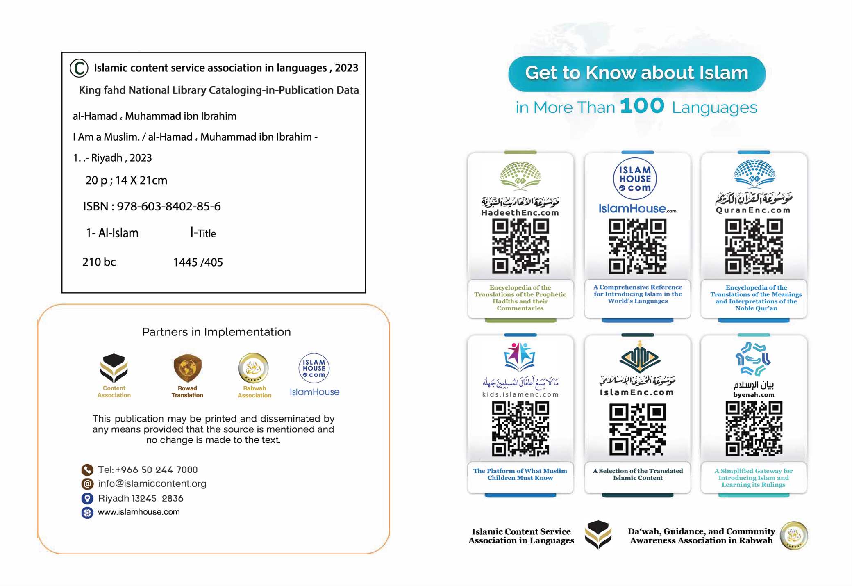

I Am a Muslim

Author: Dr. Muhammad ibn Ibrahim al-Hamad

I Am a Muslim
I am Muslim, which means my religion is Islam. Islam is such a great and magnificent word that the prophets (peace be upon them) inherited it by succession from the first of them to their last. Islam is a word that bears sublime meanings and magnificent values, as it means submission, compliance, and obedience to the Creator. It also denotes peace, safety, happiness, security, and comfort for the individual and the community. Therefore, the words 'salām' (peace) and Islam are the most frequently used words in the Islamic Shariah. As-Salām is one of the names of Allah Almighty, and the greeting that Muslims extend to one another. The greeting of the people of Paradise will be Salām (Peace)! A true Muslim is the one from whose tongue and hands Muslims are safe. In fact, Islam is the religion of goodness to all people; it understands them all and is their way to happiness in the life of this world and in the Hereafter. Thus, Islam came as the final religion that is all-inclusive, clear, and open for every person, without any discrimination based on race or color, rather it treats all people on an equal footing. In Islam, the superiority of someone over another is based only on the extent to which he commits himself to its teachings. That is the reason why it is appealing to all sound souls, due to its conformity with the human natural disposition. Every person is born with a natural inclination to good, justice, and freedom, loving his Lord, and acknowledging that He is the only deity worthy of worship apart from anyone else. No one deviates from such a natural inclination unless there is something that caused its alteration. This religion is the one which the Creator, Lord, and God has approved for the people.
Islam, my religion, teaches me that I will live in this world, then after death, I will move to another abode, that is the abode of eternity where people's destiny will either be Paradise or Hell.
Islam, my religion, orders me to abide by certain commands and prohibitions. If I fulfill such commands and avoid such prohibitions, I will attain happiness in the life of this world and in the Hereafter. Whereas, if I neglect them, I will incur misery in the life of this world and in the Hereafter, according to the extent of my negligence and failure to comply. The greatest command Islam ordered me is to believe in the oneness of Allah, for I bear witness and firmly believe that Allah is my Creator and my Deity. I worship none but Allah out of love for Him, fear of His punishment, hope for His reward, and reliance upon Him. This is called Tawhīd (monotheism), which is to believe that Allah is One, and that Muhammad (may Allah's peace and blessings be upon him) is His Messenger. He is the seal of the prophets whom Allah sent as a mercy to the worlds. He concluded by him all missions of prophethood and divine messages, and there is no prophet after him. He came with a universal religion that is valid for all times, places, and people.
My religion firmly commands me to believe in the angels and all the messengers, the head of them are Nūh (Noah), Ibrāhīm (Abraham), Mūsa (Moses), ‘Isa (Jesus), and Muhammad (peace be upon them).
It commands me to believe in the divine books that were sent down upon the Messengers of Allah, and to follow the last revealed one and greatest of them all, which is the Noble Qur’an.
My religion commands me to believe in the Last Day; where people will be recompensed for their deeds. It also commands me to believe in the Divine Decree, be content with what is predestined for me in this worldly life of good and evil, and seek to pursue the means leading to salvation.
Believing in the Divine Decree gives me comfort, reassurance, and patience and saves me from regretting what has previously happened. That is because I know for sure that what has befallen me would never have passed me and what had passed me would never have befallen me, since everything is predestined and decreed by Allah, and I only have to pursue the means, and be content with whatever takes place thereafter.
Islam further commands me to do what purifies my soul of the good deeds and refined morals that please my Lord, purify my soul, make my heart happy, expand my chest, illuminate my path, and make me a member who serves the interests of society.
The greatest of such deeds are believing in the oneness of Allah, establishing the five obligatory prayers every day and night, paying zakah, (obligatory charity) fasting on the month of Ramadan every year, and performing Hajj in Makkah for whoever can afford it.
From the best means of comforting the spirit to which my religion has guided me is to recite the Qur’an frequently. The Qur’an is the word of Allah and the most truthful, beautiful, magnificent, and majestic speech, as it includes knowledge of the past and later nations. Reciting and listening to the Qur’an inspire tranquility, serenity, and happiness to the heart, even if the reciter or listener is a non-Muslim or someone who does not know Arabic. Also, one of the greatest reasons for attaining comfort of the heart is supplicating Allah Almighty most frequently, resorting to Him, and asking Him for all one's needs, be they small or big, for Allah Almighty responds to those who supplicate to Him and worship Him sincerely.
Another major reason for the tranquility and peacefulness of the heart is remembering Allah Almighty abundantly.
My Prophet (may Allah's peace and blessings be upon him) has instructed me
how to remember Allah Almighty and taught me the best formulas with which Allah is remembered. Among these are the four words that are the best of words after the Qur’an; they are subhan Allah, al-Hamdulillah, la ilāha illa Allah, and Allahu Akbar. This means glory be to Allah, praise be to Allah, there is no god worthy of worship but Allah, Allah is the Greatest.
In addition to these, there is also astaghfirullah and la hawla wa la quwwata illa billah. This means I seek Allah's forgiveness, and there is no power or might except through Allah.
These words have such a profound effect on inspiring peacefulness and tranquility of the heart.
Islam further orders me to act in a refined manner, never compromise my humanity and honor, and employ my reason and body parts in doing such beneficial deeds for my religious and worldly affairs, and for this

purpose, I am created.
Islam enjoins me to adopt mercy, good morals, good treatment, and kindness to people with words and actions.
The greatest of the rights of people that I am commanded to observe is the right of parents. My religion commands me to be dutiful to them, wish good for them, strive to make them happy, and provide benefit to them; especially in their old age. Thus, it is noted that parents enjoy a high level of respect and appreciation in Muslim communities and are served sincerely by their children. The more the parents grow old and suffer illness or inability, the more their children show dutifulness to them. Islam taught me that women are highly honored and enjoy great rights. In Islam, women are the counterparts of men, and the best of men are those who are best for their household. As an infant, a female Muslim has the right to breastfeeding, care, and good upbringing.
She is the apple of her parents and siblings' eyes and the fruit of their hearts. When she is grown up, she is the honored and endeared young woman who is shaded by her guardian's protective jealousy and care. He is there to prevent any verbal or physical harm that could afflict her, and to protect her against the treacherous gazes of the eyes. When she gets married, her marriage is bound by the word of Allah and His solemn covenant, so she settles in her husband's house in dignity and honor. It is the duty of her husband to honor her, treat her kindly, and protect her against harm.
When she becomes a mother, her right of dutifulness is coupled with the right of Allah Almighty and offending her is coupled with Shirk (polytheism) and spreading corruption in the land.
Being a sister, she is entitled to the right to maintain ties of kinship, honor, and protection. And if she is a maternal aunt,
she is the same as a mother in terms of her entitlement to dutifulness and maintaining ties.
As a grandmother or an old woman, she becomes well respected by her children, grandchildren, and all her relatives. Her requests are not ignored and her opinions are not belittled.
When she is neither a relative nor a neighbor, she is still entitled to the general rights of Islam, including safety from harm, lowering the gaze, and others.
Muslim societies still respect these rights in a due manner. This has granted women a level of value and consideration which now are lacked in non-Muslim societies.
In addition, women in Islam enjoy the right to own property, rent, sell, buy, and engage in all other transactions. They also have the right to learn, teach, and work, as long as this does not involve violating their religion. Rather, there are some branches of
knowledge that fall under the category of individual obligation that one incurs sin for neglecting, whether male or female.
Women are even entitled to all the rights the men have except for what is specific to them to the exclusion of men, or what is specific to men to the exclusion of women in terms of rights and rulings. The rights which are typically suitable for each according to the manner clarified in the relevant topics.
My religion commands me to love my brothers, sisters, paternal uncles, paternal aunts, maternal uncles, maternal aunts, and all my relatives. It commands me to fulfill the rights of my wife, children, and neighbors.
My religion commands me to seek knowledge and urges me to adopt all things that develop thought, manners, and reason.
It commands me to adopt bashfulness, forbearance, generosity, bravery, wisdom, sobriety, patience, honesty, humbleness, chastity, integrity, and faithfulness.
It also commands me to wish good for others, strive to earn a living, show sympathy to the needy, visit the sick, fulfill promises, speak words of good, meet others with a cheerful face, and be keen to make them happy as much as I can.
On the other hand, my religion warns me against ignorance and forbids me to fall into disbelief, atheism, disobedience, immorality, fornication, sexual perversion, arrogance, envy, holding grudges, harboring evil thoughts, pessimism, sadness, lying, despair, miserliness, laziness, cowardice, idleness, anger, rashness, foolishness, abusing others, engaging in excessive useless talk, disclosing secrets, betrayal, breaking promises, not being dutiful towards parents, cutting off family relations, neglecting one's children, and harming one's neighbors or people in general.
Islam also forbids me to consume intoxicants and drugs, engage in gambling, commit theft, cheat or deceit, frighten others, spy on them, or look for their faults.
Islam, my religion, ensures the protection of property, which fosters peace and security. That is why it urges Muslims to be honest and lauds those who are honest, promising them a good life and Paradise in the Hereafter. On the other hand, Islam prohibits robbery and threatens robbers with punishment in the worldly life and in the Hereafter.
Islam protects lives and prohibits killing a person unjustly and abusing others in all ways of abuse, including verbal abuse.
It is also prohibited in Islam to commit aggression against oneself. It is impermissible for a person to impair his reason, destroy his health or kill himself.
My religion, Islam, guarantees freedoms and regulates them. In Islam, a person is free to think, sell, buy, trade, and travel, and is free to enjoy the good things of life, such as food, drink, clothing, or listen to whatever one
likes, so long as they do not commit a forbidden act that causes harm to themselves or others.
My religion controls freedoms, no one is allowed to transgress against others, or indulge in prohibited things that are detrimental to one's wealth, happiness, and humanity.
If you consider those who do whatever they want, indulging in all they desire without any limits set out by religion or common sense, then you will notice that these people are in the lowest depths of misery and distress, and some would even think about committing suicide in an attempt to find a way out from their anxiety.
My religion also teaches me the most refined etiquette with regard to eating, drinking, sleeping, and addressing others.
My religion teaches me to be lenient in selling, buying, and claiming of rights. It teaches me to be tolerant towards those who are not Muslims.
I should not wrong them or offend them, but should treat them kindly and wish that they attain what is good. The history of Muslims attests to their tolerance towards their opponents to an extent that no nation has ever experienced before them. In fact, Muslims have coexisted with nations of different faiths that fell under the dominion of Muslims who offered them the best treatment that ever existed among humans. In a nutshell, Islam has taught me the subtleties of etiquette, the most graceful methods of dealings, and the noblest manners that ensure to me peacefulness of life and complete happiness. On the other hand, it forbids me to do all what brings inconvenience to my life or jeopardizes my social position, life, mind, wealth, dignity, or honor. The more I adhere to these instructions, the more my happiness magnifies, and the more I neglect them, the more my happiness decreases.
However, it does not mean I do not commit sins or fall into error, my religion understands human nature and takes into consideration my occasional moments of weakness, where I may err and be neglectful. Therefore, Islam opens the door of repentance for me by seeking Allah's forgiveness and returning to Him, as repentance wipes away the traces of my negligence and raises my status with my Lord.
All the teachings of Islam, including beliefs, manners, etiquette, and dealings are derived from the noble Qur’an and the purified Sunnah.
Finally, I say firmly that were anyone living anywhere in the world to know the truth of Islam with the eyes of justice and impartiality, would do nothing but embrace it. But, unfortunately, Islam is unjustly defamed by false claims, as well as acts of some Muslims who do not adhere to its teachings.
Were anyone to look at Islam in its true sense, or consider the behavior of truly committed Muslims, would never hesitate to accept and embrace it, and would eventually realize that Islam calls for the happiness, peace, and safety of mankind, and the spread of justice and kindness. As for the deviant actions of some of those who are considered Muslims, they must never be attributed to Islam, or considered as faults and shortcomings, but Islam is free of all such negative aspects. The repercussions of such deviation should belong to the perpetrators themselves, for Islam did not command them to do so, rather, Islam prohibits and forbids them from deviating from its sublime teachings. Moreover, justice necessitates that Islam should be perceived through the state of those who uphold the religion as due, and those who implement its commandments and rulings with regard to themselves and others, for this fills the hearts with reverence and
respect towards this religion and its people. Islam does not leave a minor or major issue related to guidance and discipline except that it encourages it, nor does it leave an issue related to evil and vice except that it warns of it and blocks the means to it.
Therefore, those who honor its status and establish its rites are the happiest of people and the highest in disciplining and raising their selves upon the best qualities and noblest manners, which is attested by far and wide, as well as those who are in agreement or opposition to it.
However, judging Islam based on the actions of people who have diverted from its straight path is not just rather, it is unfair.
Finally, this is an invitation for every non-Muslim who wants to know about Islam and embrace it.
Someone who wants to embrace Islam should only bear witness that there is no god worthy of worship except Allah and that
Muhammad is the Messenger of Allah, and learn the religious knowledge essential for performing what Allah has made obligatory on him. The more one increases in knowledge and lives by it, the more his happiness increases and his rank is raised with his Lord.

*****

A word written for introducing Islam.

