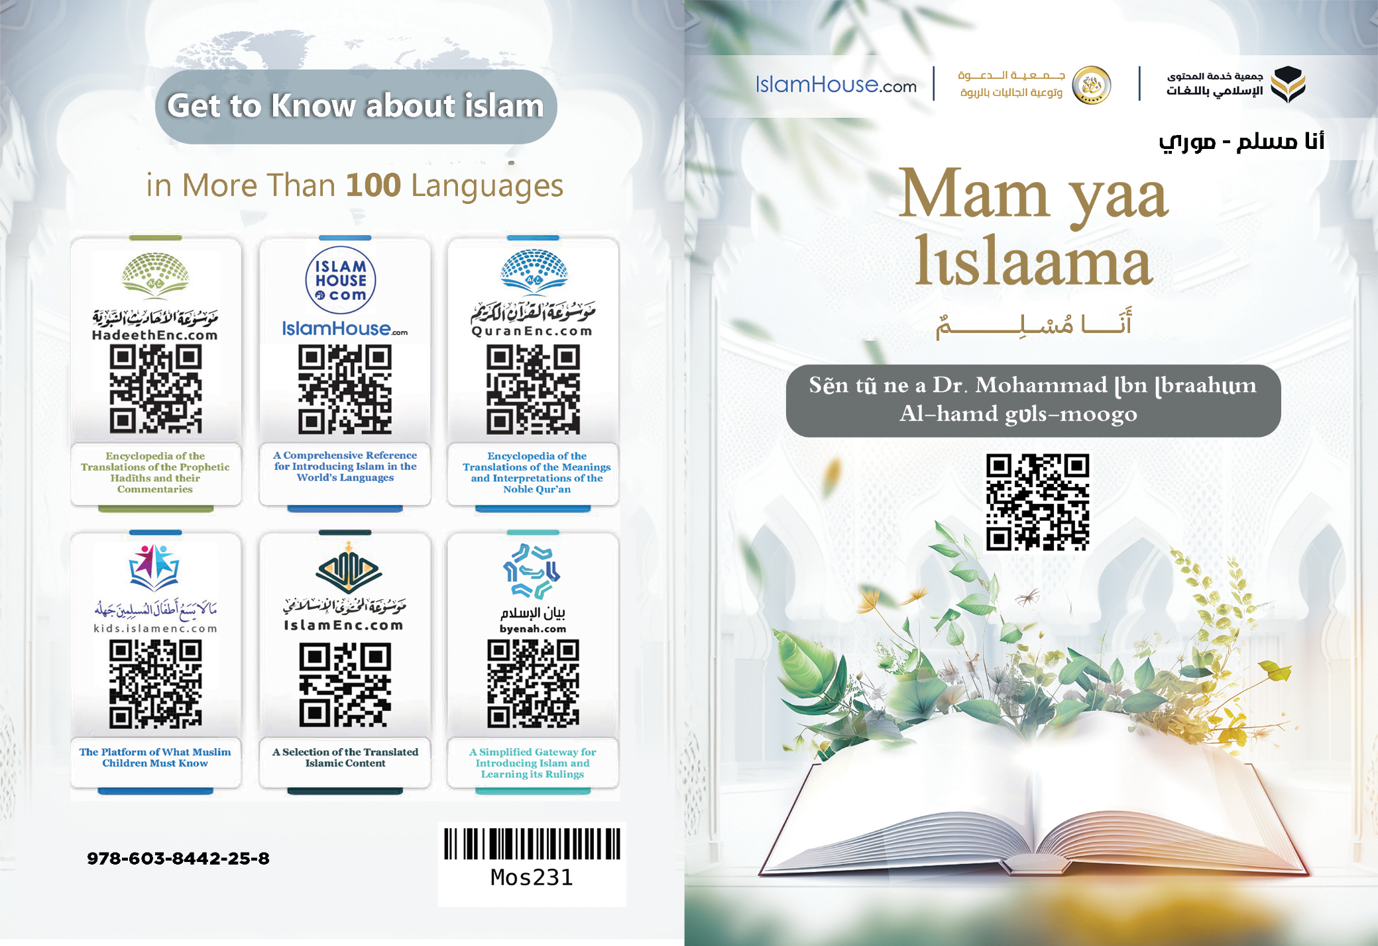
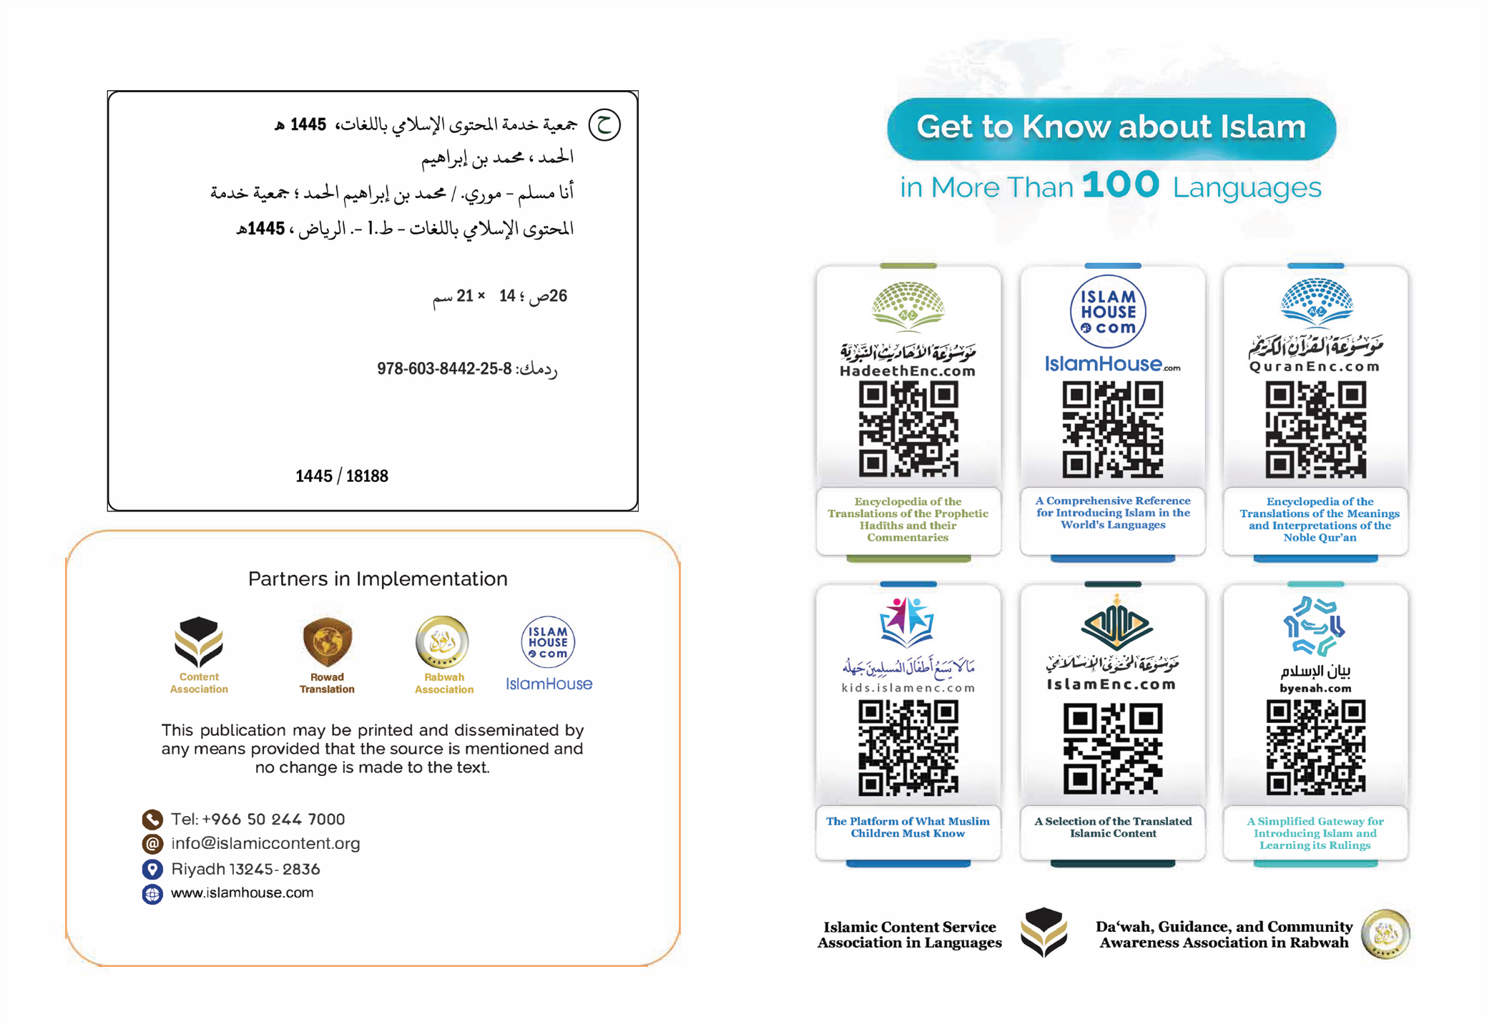

Mam yaa lɩslaama

Sẽn tũ ne a Dr. Mohammad ɭbn ɭbraahɩɩm Al-hamd gʋls-moogo

Mam Yaa lɩslaama
Mam yaa lɩslaama, la rẽnda rat n na n yeelam tɩ mam dĩinã lɑ lɩslaoongã, La lɩslaoongã yaa gomd sẽn yaa zɩsgo, sẽn yɩlge, tɩ nabiyaam-rãmbã rɩk a faado, -tɩlgr be b yĩnga-, sẽn sɩng b sɩngrã n tɩ tãag b baasgã; La gomd-kãngã, a zãada maana sẽn zẽke la zʋgd sẽn yaa zɩsgo; Bala a rat n na n yeelame tɩ lɩslaoong yaa sak-n-tũ la pʋgbo la tũudum ne Naandã, A leb n rat n na n yeelame tɩ yaa tɩlgre la laafɩ la zu-noogo la bas-m-yam la vʋʋsgo n kõ nin-yεnga la zãmã wã. Woto n kɩte, tɩ gom-biisi sẽn yɑɑ : "tɩlgre la laafɩ" nɑɑgɑ gom-biis nins sẽn yɩɩd wɑooglem sẽn wa Šari wã pʋgẽ; Rẽnd salaamã (tɩlgrã) yaa yʋʋr sẽn be Wẽnd yʋɩ yã pʋgẽ, La lɩslaambã pʋʋsgo bãmb ne taab sʋka, yẽnda yɑɑ Assalaam (tɩlgrã), La arzãn kɑmba pʋʋsgo yaa (tɩlgre) salaam, La lɩslaam sɩd-sɩda yaa lɩslaambã sẽn tɩlge n yi a zelemdã, la a nugã wẽngɑ; Rẽnd lɩslaoongã yaa sõma dĩin ne nebã fãa gilli, a sekda nebã fãa, yẽ n leb n yaa b zu-noog sore dũni wã la laahre, Rẽnd n kɩt t'ɑ wa n pidsdẽ, n gũbgi, n yaa yalanga, n yaa vẽenega, n pake n togel ned fãa gilli, a ka welgd buudu ne a to ye, ka kõbg ne a to, a geta nebã fãa gilli ges yenda; la ned ka welgd ne sõmblem n yɩɩd ɑ tɑɑbã lɩslaoongã pʋgẽ, rẽndame tɩ yɑɑ sẽn zems yẽ me sẽn sak n pʋgd lɩslaoongã alkadre. Rẽ n kɩt tɩ yõy nins fãa sẽn tar laafɩ wã sakd-a, bala yaa bũmb sẽn kell n zems ne nebã Fɩtrɑ (reg-ne) wã; Rẽnd ninsaal fãa gill rogdame tɩ yaa b sẽn naan-a t'a nong sõma, la tẽeg-tɩrga, la burkĩndi, n nong a Soabã, n sak n reg a zugẽ, tɩ Yẽnda la b sẽn tũud a soaba sẽn sõmbɑ tɩ b tũ-A Yẽ A Yembre, n bas zẽng sẽn ka yẽnda; La ned ka gõdgde n yi Fɩtrã (Rog-ne) kãngã, rẽndame tɩ yaa bũmb n tedg-a, La dĩin-kãngã, yaa nebã Naandã n yar-a n kõ ne-bã, sẽn yaa b Soabã, la b Tũudã.
La mam dĩinã sẽn yaa lɩslaoongã wilgda maam tɩ mɑm na n vɩɩma dũni-kãngã pʋgẽ, la mam kũumã poorẽ, m na n tedgame n kẽng zak a to, yẽnda me la paab zakã, zĩig ning nebã bɑɑsg sẽn yɩt ɑ pʋgẽ, maa tɩ yaa arzãnẽ maa bugmẽ.
La mam dĩinã sẽn yaa lɩslaoongã sagenda maam ne saglse, la a gɩdgd maam n yi yel-gɩɩtɩ; Tɩ mam sã n yik ne sagl-kãensã la m zãag gɩdg-kãensã, m paamda zu-noogo dũni wã kaanẽ la laahre, La m sã n maan yam yaal-yaal a pʋgẽ la zu-beed sẽn paam maam dũni kaanẽ la laahre, sẽn zems ne mam kʋɩɩngã la m koeegrã tεka, la lɩslaoongã sẽn sagend maam ne bũmb tɩ yaa zɩsg n tʋg n yɩɩda, yaa Tawhɩɩdʋ (Wẽnd-yembgã); Rẽnd mam maanda kaseto la m loet loεεga sẽn kenge: tɩ Wẽnd la mam Naandã, la mam sẽn tũuda Soabã; Rẽnd m ka tũud tɩ sã n ka Wẽnd ye; tɩ yaa nonglem ne-A, n leb n yaa yεεsg n yi A namsgã, n yaa tẽebo ne A yel-sõmdã, n yaa bobl-m-meng ne-A, La Tawhɩɩdã (Wẽnd-yembg) kãngã, a bee ne fo sẽn na n maan kaset ne Wẽnde, t'A yaa A Yembre, la A Nabiyaam a Mohammad ne Tẽn-tʋmdã; Rẽnd a Mohammad yaa nabiyaam-rãmbã pidsda, Wẽnd tʋms-a lame tɩ yaa yolsgo ne bõn-naandsã la A pids nabiyaamdmã la tẽn-tʋmdmã ne-a, rẽnd nabiyaam ka be a poorẽ ye, La a waa ne dĩin sẽn gũbgi, n sɑkd tʋʋmɑ wakat fãa la zĩig fãa pʋgẽ.
La mam dĩinã sagenda maam saglg sẽn kenge, tɩ m kõ sɩd ne malεgsã la nabiyaam-rãmbã fãa gilli, la b zu-raoogã yaa a Nuuhu, la a ɭbraahɩɩma, la a Muusa, la a ɭɩsa, la a Mohammad -tɩlgr be b yĩnga-.
A leb n sagenda maam tɩ m kõ sɩd ne saasẽ Gaf-rãmb nins b sẽn sik tẽn-tʋʋmbã zugã, la m tũ b baasdgã la b pidsdã la sẽn zɩsa n yɩɩda, yẽ me la (Alkʋrãan wagellã).
La mam dĩinã sagenda maɑm tɩ m kõ sɩd ne yaoolem raarã, b sẽn na n rol nebã raar ning pʋgẽ, b tʋʋmã, la ɑ sagenda maam tɩ m kõ sɩd ne kordgo (Pʋlengã) la m yar ne bũmb ning sẽn yɩte n paamd maam dũni-kãngã vɩɩma pʋgẽ, sẽn yaa sõma maa wẽnga, la m kẽne n rɩk tɩlgrã sabab-rãmba. La kõ sɩd ne kordgã (Pʋlengã) a kõta maam vʋʋsgo la yĩ-yũgnego la sugri la m bas nimis mɑɑneg ne bũmb ning sẽn looge; bala maam, m miime minim sẽn yaa vẽenega, tɩ bũmb ning sẽn paam maamã, a ka yɩ n na n põsg maam ye, la bũmb ning sẽn põsga maamã ka yɩ n na n paam maam ye, Rẽnd bũmbã fãa gilli yaa sẽn pʋlme n gʋlse n yi Wẽnd nengẽ, la ka be ne maam rẽnda mam rɩk sabab-rãmbã bala, la m yar ne bũmb ning sẽn yɩt rẽ poorẽ wã.
La lɩslaoongã sagenda maam ne bũmb ning sẽn na yɩ yɩlgemd ne mam yõorã, sẽn yaa tʋʋm sõmbse, la zʋg bεda, sẽn yard Wẽndã, la ɑ yɩlgd mam yõorã n yɩlgd m sũurã, n yalgd m yãoogã, la a vẽnegd mam sorã, Lɑ ɑ maand tɩ mam yaa ned sẽn nafde zãmã wã pʋgẽ.
La tʋʋm-kãensã sẽn ya ɑ zɩsg n yɩɩdɑ , yaa: Wẽnd-yembgã, la Wakat a nu wã Pʋʋsgo yʋng la wĩndga, la arzεkã zak kũuni, la kiuug no-loeere yʋʋmdã pʋgẽ, yẽ me la Ramadaanã kiuugu, la Lohorem Roogã kaagre, sẽn be Makã, ne ned ning sẽn paama hagiimdã tõogo.
La sẽn leb n yaa zɩsg n yɩɩd mam dĩinã sẽn tees maam n tʋg-ɑ, n yaa sẽn yalgd yãoogã, ɑd yaa Alkʋrãanã kareng wʋsgre, sẽn yaa Wẽnd goamã, n yaa goam sẽn yɩɩd ne sɩdã, n yaa goam sẽn yɩɩd neerem la zɩslem, n yaa goam sẽn yɩɩd taglem, sẽn gũbg rẽenem-rãmb la yaoolem-rãmb bãngrã; Rẽnd a karengã maa a kelgrã kẽesda yĩn-yõgnego la vʋʋsgo la zu-noogo sũurẽ wã, baa tɩ karemdã maa kelegdã ka wʋmd laarabiimdu maa a ka more. La yell sẽn leb n yɩɩd sẽn yalgd yãoogã, yaa Wẽnd kosgã wʋsgre, la lebs-m-meng A nengẽ, la A bõosgo sẽn yaa bõn kɩdg la sẽn yaa bedr fãa; Rẽnd Wẽnd sɑkda ned ning sẽn bool-A la a yɩlg a tũudmã ne-A.
La sẽn leb n yɩɩd sẽn yalgd yãoogo, yaa Wẽnd yʋʋrã tẽegr wʋsgo -A Nɑɑm yɩ wagell n zẽke-.
La sɩd la hakɩɩka mam Nabiyaamã -Wẽnd pʋʋsg la A tɩlgr be a yĩnga-a teesa maam n tʋg Wẽnd yʋʋrã tẽegr sẽn yɩt to-to, la a wilg maam bũmb sẽn yɩɩd sõma mam sẽn na n tẽegd Wẽnd yʋʋrã ne-a, La sẽn be rẽ pʋgẽ yaa gom-biis a naas nins sẽn yɩɩd sõmblem Alkʋrãan poorẽ, bãmb me lɑ : (Sʋbhaanallaah walhamdʋ lɩllaah, wa laa'ɩlaaha ɩllallah, wallaahʋ akbarʋ= yɩlgemd be ne Wẽnde, pẽgr be ne Wẽnde, soab sẽn na n tũ n tɩlg ka be, tɩ sã n ka Wẽnde, la Wẽnd n yɩɩd bedrem).
La woto bala (Astagfɩrʋllaah, walaa hawla wala ƙʋwwata ɩllaa bɩllaahɩ= m kota Wẽnd yaafa, la sɩlem ka be, la pãng ka be, rẽndɑ ne Wẽnde).
Rẽnd gom-kãensã tara vũun sẽn yaa yel-solemde sũya yalgr wεεngẽ, la yĩn-yõgneg sigb sũurẽ wã.
La lɩslaoongã sagenda maam tɩ m yɩ alkadr zẽkdg soaba, n zãag m meng ne bũmb ning sẽn paoogd mam nedemdã la m waoorã, La m tʋm ne m yamã la m yĩn-wilã, b sẽn naan maam bũmb ning yĩngã pʋgẽ sẽn yaa tʋʋm nɑfdi, m dĩinã pʋgẽ la m dũni wã pʋgẽ.
La lɩslaoongã sagenda maam ne yolsgo la zʋg sõngo, la tʋmd-n-ta noogo, la man-neere n tʋg bõn-naandsã, m sẽn tõe fãa ne goɑm la tʋʋma.
La b sẽn sagl maamã sẽn tʋg n zɩs n yɩɩdɑ bõn-naandsã hakε-rãmba wεεngẽ, yaa roagdb a yiibã hakε, rẽnd mam dĩinã sagenda maam tɩ m maneg b yiibã, la m bʋ nonglem ne b yiibã, la m maan yã-beedo ne b yiibã sũur noogre, la m kõ-b sẽn nafd-ba, la sẽn tʋg n yɩɩda yaa b sẽn wat n lebg kasembã wɑkɑtã; Woto n kɩt tɩ fo yãt ma-rãmbã lɑ baabã-rãmbã lɩslaambã zĩisẽ, tɩ b be dargε sẽn zẽk pʋgẽ, sẽn yaa waoore, la zẽkre, la sõgnego sẽn yi b yiibã koambẽ, La roagdb a yiibã sẽn lebg kãsemb n paas fãa, maa bãag n yõk-ba, maa kongre, la koambã manegr sẽn paasd ne-ba Mam dĩinã leb n wilga maam tɩ paga ɑ tara waoor sẽn zẽke, la hakε-rãmb sẽn yaa zɩsgo; Rẽnd pagbã lɩslaoongã pʋgẽ, b yaa rapa bogse, lɑ nebã sõmblem sẽn yɩɩda, yaa sẽn yaa sõma ne a zak-rãmba; Rẽnd lɩslaam poaka, a yãadremẽ wã, a tara hakε sẽn yaa yẽsẽngo la zãɑbo, la a wubrã manegre, la yẽnda wakat-kãng pʋgẽ fãa gilli, a yaa nif maagre, n leb n yaa sũur tɩ-bila ne a roagdb a yiibã la a ma-biisã. La a sã n wɑ bɩ, a lebgda b sẽn zɩsgd a soaba la b sẽn waoogd a soaba, b baabã-rãmbã zɑbdɑ Rɑ-tɑɑdo b poorẽ la b gũbgd-a ne ges-neere, Rẽnd b ka yarde tɩ wẽng nug wa tʋg n zẽk n kẽng a nengẽ ne wẽng ye, maa zelma ne nɑmesg ye, ka nin gesg ne zãmb me ye. La a sã n furi, rẽnda yɩta ne Wẽnd gomde, la A alkaoolã sẽn yaa zɩsgã; rẽnd a yɩtame n be a sɩdã zakẽ zĩnd-n-tɑɑr sẽn yɩɩd sõmblem zĩigẽ, tɩ yaa tɩlae n rog a sɩdã t'a waoog-a, la a maneg-a la a yõk nong n yi-a.
La a sã n yaa ma, a manegrã yaa bũmb sẽn tõk ne Wẽnd hakε wã, -A Naam zẽkame- la a namsgo la mɑɑn wẽng n tʋg-a, yẽ me yaa bũmb sẽn tõk ne lagem-n-taar mɑɑneg ne Wẽnde la sãang tẽngã pʋgẽ.
La a sã n yaa tão, yɑɑ yẽ la b sẽn sagl lɩslaam t'a tõk-a wã, la a waoog-a la a zab ra-taar a poorẽ, la a sã n yaa ma-bila (mɑ wã tã-poɑkɑ), a yɩta wala ma wã sẽn yɑɑ soɑbã, manegr la tõkr wεεngẽ.
La a sã n yaa yaab-poaka, maa a kʋʋlɑme, laa a tɩrlemã(valεεrã) sẽn paasde, a koambẽ la a yagensẽ wã la a rog-pẽtbã fãa nengẽ; rẽnd yaa toog t'a kos bũmb n ka paam ye, b leb n ka paoogd a koεεg ye.
La a sã n yɩɩme n zãr ne nedã, n ka pẽ-ɑ ne rogem maa yak-n-taare, a tara lɩslaoongã hakε-rãmb nins sẽn gũbgã, sẽn yaa nang yõk-n-yi neda, la nin-mumbu la zẽng sẽn ka yɩ ne rẽnda.
La lɩslaambã tems ka bak n gũusd hakε-kãensã gũusg tεkẽ, rẽ kɩt tɩ pag wa tar tɩrlem la ɑ kɑɑlgo, wɑoogr ningɑ ɑ sẽn ka tõe n pɑɑm zãma-rãmb nins sẽn ka moeembã nengẽ.
Rẽ poorẽ, lɩslaoongã pʋgẽ, pag tara hakε n tõe n soog bũmbu, la a luwaase, la a koose, la a ra, la tʋmd-n-taarã loeesã fãa gilli, a leb n tara hakε n na n kareme la a karem neba, la a tʋm bũmb ning sẽn ka yõsgd ne dĩinã, pʋs n ka woto ye, ɑd bee bãngrã pʋgẽ bɑoob sẽn yaa tɩlae n rog ned fãɑ zugu, t'a basd paamd zunuubu, zem tɩ yaa raoa maa tɩ yaa paga.
Pʋs n ka woto ye, ɑd bee ne-ɑ bũmb ning sẽn be ne raopã, sã n ka wala bũmb ning a sẽn welgd ne tɩ ka tũ ne raopã, maa ne bũmb ningã rɑopã sẽn welg ne wã, tɩ ka tũ ne pagã, tɩ yaa hakε-rãmba la bʋʋd-rãmba sẽn zemsd ne ned fãa gill yalẽ, wala b sẽn wels yel-kãensã b zĩisẽ wã.
Mam dĩinã leb n sagenda maam tɩ m noang m tãopã la m tãop-pogsã, la mam sãmbɩb-rãmbɑ lɑ m pʋgd-rãmbɑ, la m yεs-rãmba la m mɑ-bi wã, la mam rog-pẽtsã fãa, la a sagend maam tɩ m yãnes ne m pɑgã hɑkε-rãmbã la m koambã la m yagsã.
Mam dĩinã sagenda maam ne bãngre la a kenged maam ne bũmb fãa sẽn paasd mam yamã la m zʋgdã la m tagsã.
La a sagend maɑm ne yãn-zoεεga, la sugri, la kũuni, la roɑdo, la yam-bedre, la maag-m-menga, la sugri, la bas-m-yam, la gãneg-m-menga, la yõk-m-menga, la pʋ-peelem, la alkaool pidsgu, la neer nonglem ne nebã, la tʋme n bao rɩtla, la nimbãan-zoεεga ne nimbãan-neba, la bãɑd-rãmb kaagre, la pʋlʋng pidsgu, la gom-noodo, la sεg nebã ne no-yõgengo, la tall nong-kεgεnga ne b sũyã noogre, m pãng tõog tεka.
La sẽn kɩɩsd woto, a bugsda maam n yit zɩɩlem la a gɩdgd maam n yit kɩfẽndo, la raεεgre, la Wẽnd kɩɩsgo la yel-beedo, la yoobo, la kedgre kẽed-n-taar wεεngẽ (rɑop ne tɑɑb kẽed-n-tɑɑre), la waoog-m-menga, la sũ-kiiri, la beem, la tẽ-wẽng ne nebã, la wẽng tẽeb yεlɑ pʋsẽ, la sũ-sãanga, la zĩri-beedo, la tẽeb wãagre, la beedo, la kʋɩɩngo, la rabeem, la bas tʋʋma, la gẽega, la yalamdo, la mɑɑn nebã wẽngɑ, la gom wʋsg tɩ ka tar yõodo, la yel-soondɩ pukri, la zãmbo, la pʋlʋng viigri, la roɑgdb a yiibã namsgo, la rogem wãagre, la koamb base n ka get-ba, la yak namsgo la bõn-naandsã gilli.
La lɩslaambdã leb n gɩdgda maam n yit bõn-suudi wã yũubu, la dorg-rãmb rɩkre, la war tãoob ne arzεka, la wagdem, la zãmbo, la belgre, la nebã pεlens yɩkre, la b yεlã pẽes-n-bãnge, la b yãnã pʋgbo.
La mam lɩslaoongã dĩina, a gũuda arzεgsã, la bee rẽ pʋgẽ, sẽn yɑɑ laafɩ la bas-m-yam sẽegre, rẽ n kɩt t'a keng tɩ b maan bas-m-yam, la a pẽg b rãmbã, la a pʋlʋm-ba ne vʋɩ-noogo la arzãn kõom laahr raarã, la a gɩdg wagdem, la a pʋlʋm a maandã pʋlʋng beedo, sɩbgre dũni kaanẽ, la laahr raarã.
La mam dĩinã, a gũuda yõore, rẽnd n kɩt t'a gɩdg yõor kʋʋbo, tɩ sã n ka tũ ne hakε, la maan-n-zʋʋg neb a taabã zugu, sẽn yaa kõbg ning fãa maan-n-zʋʋkã pʋgẽ, baa tɩ yaa ne gom-biisi.
Ka woto ye, a gɩdgame tɩ ninsaala ra wa tʋg n maan n zʋʋg a mengã zug ye, rẽnd b ka kõ sor ne ninsaala, t'a wa sãam a yamã, maa a laafɩ wã, maa a kʋ a menga ye.
La mam dĩinã sẽn yaa lɩslaoongã, a kõo nebã maan-m-yamã la a remsd-ɑ lame n yõgn-ɑ; Rẽnd ninsaala lɩslaoongã pʋgẽ, a yaa burkĩna a tagsã pʋgẽ la a koosgẽ, la a raabẽ, la a tolbẽ wã, la a kẽnã pʋgẽ, a leb n yaa burkĩna ne a maan wʋm-noogo ne vɩɩmã yel-noodã, sẽn yaa bõn-rɩtɩ, la bõn-yũudɩ, la bõn-yerdɩ, maa sẽn kelgde, t'a sã n ka maan bũmb sẽn yaa Sãri wã sẽn gidge (haraam), tɩ na n lebg n nams yẽndã mɑɑ zẽng sẽn ka yẽ.
La mam dĩinã, a zaa maan-m-yamã, rẽnd a ka kõt sore tɩ ned wa tʋg n maan n zʋʋg a to zug ye, ka ned me kell bɑlɑ n tud n mɑɑnd a wʋm-noodã pʋsẽ haraam-dãmba ye, sẽn sãamd ɑ arzεgse, la ɑ vʋɩ-noogã, la ɑ nedemdã.
La f sã n ges neb nins sẽn kõ-b mens burkĩndã, bũmbã fãa pʋgẽ wã, la b kõ b yõyã a sẽn rat bũmb ning fãa gillã, sẽn yaa yõorã-yɑmleedã, - tɩ dĩin ka tõog n gɩdg-ba, maa yam - fo na n mikame tɩ bãmbã rãmbã b vɩɩ zu-beedo la pakre sẽn tʋg n ta yaalg tεkẽ, la fo na n yãa b sãndɑ t'ɑ rat n na n kʋ a menga, tɩ yaa sẽn na paam n yiis a mengã, pεlεn-yɩk ning yẽ sẽn be wã pʋgẽ.
La mam dĩinã wilgda maam zʋgd sẽn yaa zʋg wagla, rɩɩbẽ, la yũubẽ, la gõeemẽ, la gom ne nebã pʋgẽ.
La mam dĩinã wilgda maam bas-tɩ-looge, koosmẽ, la raabẽ, la hakε wã baoob wεεngẽ, la a leb n wilgd maam bas-tɩ-loog ne neb nins sẽn yõsgd maam dĩinã pʋgẽ wã, rẽnd m ka wẽgd-ba, m ka maand wẽng n tʋg-ba, ka woto ye, m pʋs n manegd-b lame la m rat tɩ sõma ta-ba. La lɩslaambã kʋdemdã maanda kaseto tɩ b rag n da yaa bas-tɩ-loog-rãmba ne sẽn yõsgb bãmbã wã, bas-tɩ-loog ninga zãma sẽn ka tol n bãng-ɑ sẽn rengb bãmb tɑoorã; Bala lɩslaambã vɩɩma ne zãma a taaba, dĩin-rãmb sẽn yɑɑ toɑy-toɑy, n be lɩslaambã bʋʋd soolmẽ, rẽnd lɩslaambã rɑ yɩɩme n tʋmd ne nebã gill fãa, tʋmd-n-taar ning sẽn wa n tʋg n yaa sõma n yɩɩd nebã ne taab sʋka. La sẽn na gũbg bala, yaa tɩ lɩslaoongã wilga maam zʋg-wagla la tʋmd-n-taar sẽn be neere, zʋgd ning mɑm vɩɩmã sẽn yɩlgd ne-ɑ, tɩ m sũ-noogã pidi ne-ɑ, A leb n gɩdga maam n yi bũmb ning fãa sẽn gudgd mam vɩɩmã la sẽn namsd nebã vɩɩm-n-tɑɑrã, maa yaa yõorã, maa yaa yamã, maa yaa arzεka, maa yaa zɩslmã, maa yaa burkĩndã. La mam sẽn tõog n tũ togs-kãensã tεkɑ la mam zu-noogã wʋsgda, la mam sẽn maan kʋɩɩngo lɑ koeegre ne bũmb a pʋgẽ fãɑ la mam zu-noogã sẽn boogde, n zems alkadr ning mam sẽn base sɑgl-kãensã pʋgẽ wã.
La sẽn loogã ka wiligd tɩ mam yaa neda b sẽn gũ n yi tudgr ye, la m ka maand n koeeg ye, bala mam dĩinã, a gũusda mɑm ninsaaldmã yalẽ wã, la mam valengã wakat sãndɑ wã, tɩ tudgri la kʋɩɩng paamd maam, rẽ n kɩte t'a pak tuubg ragnoore n kõ maam, la zunuub yaafg kosgo, la lebs-m-meng Wẽnd nengẽ. Rẽnd tuubgã, a yẽesda mam koeegrã vũunã, la a zẽkd mam alkadrã mam Soabã nengẽ.
La lɩslaoongã dĩinã saglsã fãa gilli, sẽn yaa aƙɩɩda (loεεga) la zʋgdo, la zʋglgo, la tʋmd-n-taare, b yẽgrã yaa Alkʋrãan wagellã la Sunnah sẽn yɩlgã.
La sẽn na n baase, m yetame tɩ m sũur-kegme: lak tɩ ninsaal fãa sã n lɩk n yã, sẽn yɑɑ zĩig ning fãã dũni wã pʋgẽ, lɩslaoongã dĩinã hakɩɩka ne tẽeg-tɩrga la pidg n yi yõor yamleoog gesgo, a ka tar a sẽn na n maanegɑ, rẽndame t'a kẽ-a, la ad masɩɩbã (yellã) yaa tɩ lɩslaoongã dĩinã moon zĩri-beedã n sãam a yʋʋrã, maa sẽn yet b yaa lɩslaambã sãnda tʋʋma, sẽn yaa neb nins sẽn ka tʋmd lɩslaamdã raabã.
La ned sã n rag n ges lɩslaoongã hakɩɩka wala a sẽn yaa a soabã, maa a na n gesa neb nins sẽn yãs ne-a sɩd-sɩdã alhaalã, a kõ n maan yam yuus-yuusi ne a sakrã la a kõomã pʋgẽ ye, Lɑ rag n na n vẽnega ne-a tɩ lɩslaoongã, a boondame n tʋgd ninsaalbã zu-noogo, la laafɩ la bas-m-yam kẽesgo, la tẽeg-tɩrga la mɑnegr sẽegre. La sã n yaa neb nins sẽn yeel tɩ b yaa lɩslaambã kedgrã, zem tɩ paoodame maa yaɑ wʋsgo, ka sõmbe, sẽn wa n yaa a soab fãa tɩ b rɩk rẽnda n geel dĩinã ye, maa b zang dĩinã rẽ yĩng ye, ka woto ye, ad Dĩinɑ zãaga ne rẽnda, La kedgrã yellã, a lebgdame n rʋʋgd kεdgdbã bala, bala lɩslaoongã, a ka sagend ne rẽ ye; a pʋs n gɩdg-b lame la a bugs-ba tɩ b rɑ wɑ kedg n yi bũmb ning a sẽn wa ne wã ye. Rẽ poorẽ, sẽn paasde yaa tɩ sã n yaa tẽeg-tɩrga, sõmbame tɩ b ges neb nins sẽn yãs ne dĩinã sɩd-sɩdã halhaale, la neb nins sẽn maand a saglsã la a Bʋʋdã, b mensẽ wã , lɑ sẽn ka bãmb mensẽ wã, bala rẽnda pidisda sũya waoore la zɩsgre ne dĩin-kãngã la a rãmbã; Bala lɩslaoongã, a ka bas bũmb bilfu maa bedre, sẽn yaa peegre la zʋglgo, rẽndame t'a piris nebã a zugu, leb n ka bas zʋg wẽnga, maa sãanga, rẽndame t'a bugs n yi-a, la a gɩd a sorã.
Rẽ n kɩt tɩ neb nins sẽn waoogd a yellã, neb nins sẽn yãs ne a vũun-rãmbã, bãmb n yɩɩd nebã ne zu-noogo, bãmb n leb n be zĩig sẽn zẽk n yɩɩdɑ sã n yaa ne yõor zʋglgẽ la a wubri, ne zʋg sõmbse la zʋg wagla, tɩ sẽn pẽ-bɑ la sẽn zãr-ba, fãa maandɑ kaset ne-ba yel-kãngɑ pʋgẽ, la neb nins sẽn zemsd ne-bɑ la sẽn yõsgd-bɑ fãa maanda kaseto.
La sã n yaa gesg bala, n tʋg lɩslaɑmb nins sẽn yaa yam yaal-yaal rãmb b dĩinã pʋgẽ yεlẽ wã, neb nins sẽn gõdg-b n yi sor-tɩrgã, yẽnda ka tẽeg tɩrg bʋʋd pʋgẽ baa fʋɩ, a pʋs n yaa wẽgd menga.
La sẽn na n baase, ad wãnde yaa boolle, ne ned ning fãa sẽn ka lɩslaama, t'a maan yẽ-beedo ne lɩslaoongã sẽn yaɑ soɑb bãngre, la a kẽ a pʋgẽ.
La pɑ zɑo ned ning zug sẽn rat n kẽ lɩslaoongã pʋgẽ, sã n pɑ ɑ maan kast bɑlɑ tɩ : "soab sẽn na tũ n tɩlg ka be rẽnda Wẽnde, la a Mʋhammad me yaa Wẽnd Tẽn-tʋʋma =Ašhadʋ ãn laa'ɩlaaha ɩllallaah, wa Ašhadʋ ãnna Mʋhammadan Rasʋʋlʋ Allaah, la a karem dĩinã bũmb ninga a sẽn na tõog n yik n yals ne Wẽnd sẽn maan tɩ yaa tɩlae n rog-a wã sẽn tũ ne bãng kãngɑ, La ɑ sẽn paas bãngr la tʋʋm fãa, la a zu-noogã sẽn paasde, t'a dargε wã zẽk a Soabã nengẽ.

.Wã yaa gomd sẽn gʋlse, n na n wilg lɩslaoongã sẽn yaa a soaba

