 |  |  |  |  | 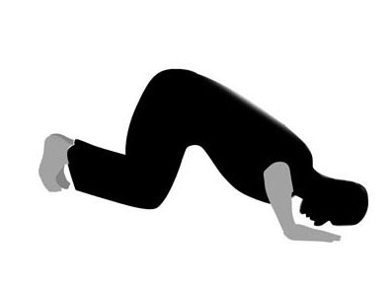   |  | 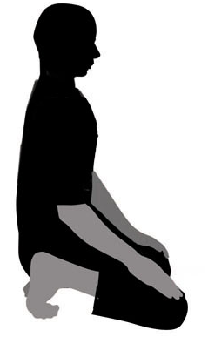 |  | 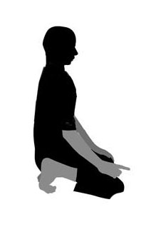
13 | Same as the first Rak'ah |  |  |  |  |  |  |  | 14

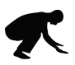
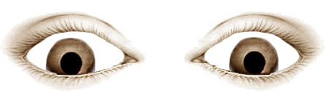

The eyes
✗ ✗ ✗ ✓
✗
✗
✗

