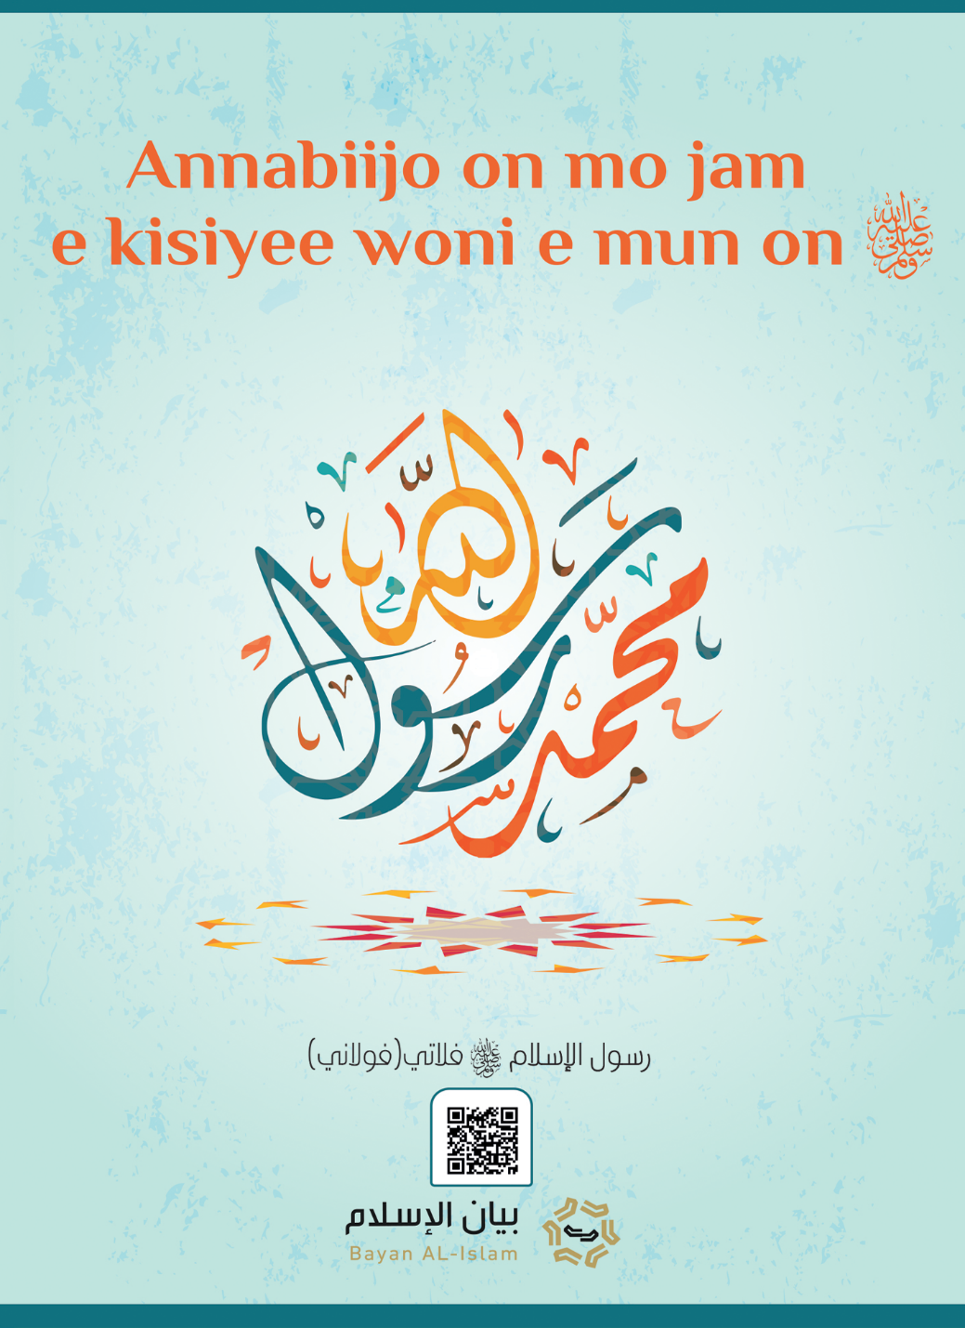
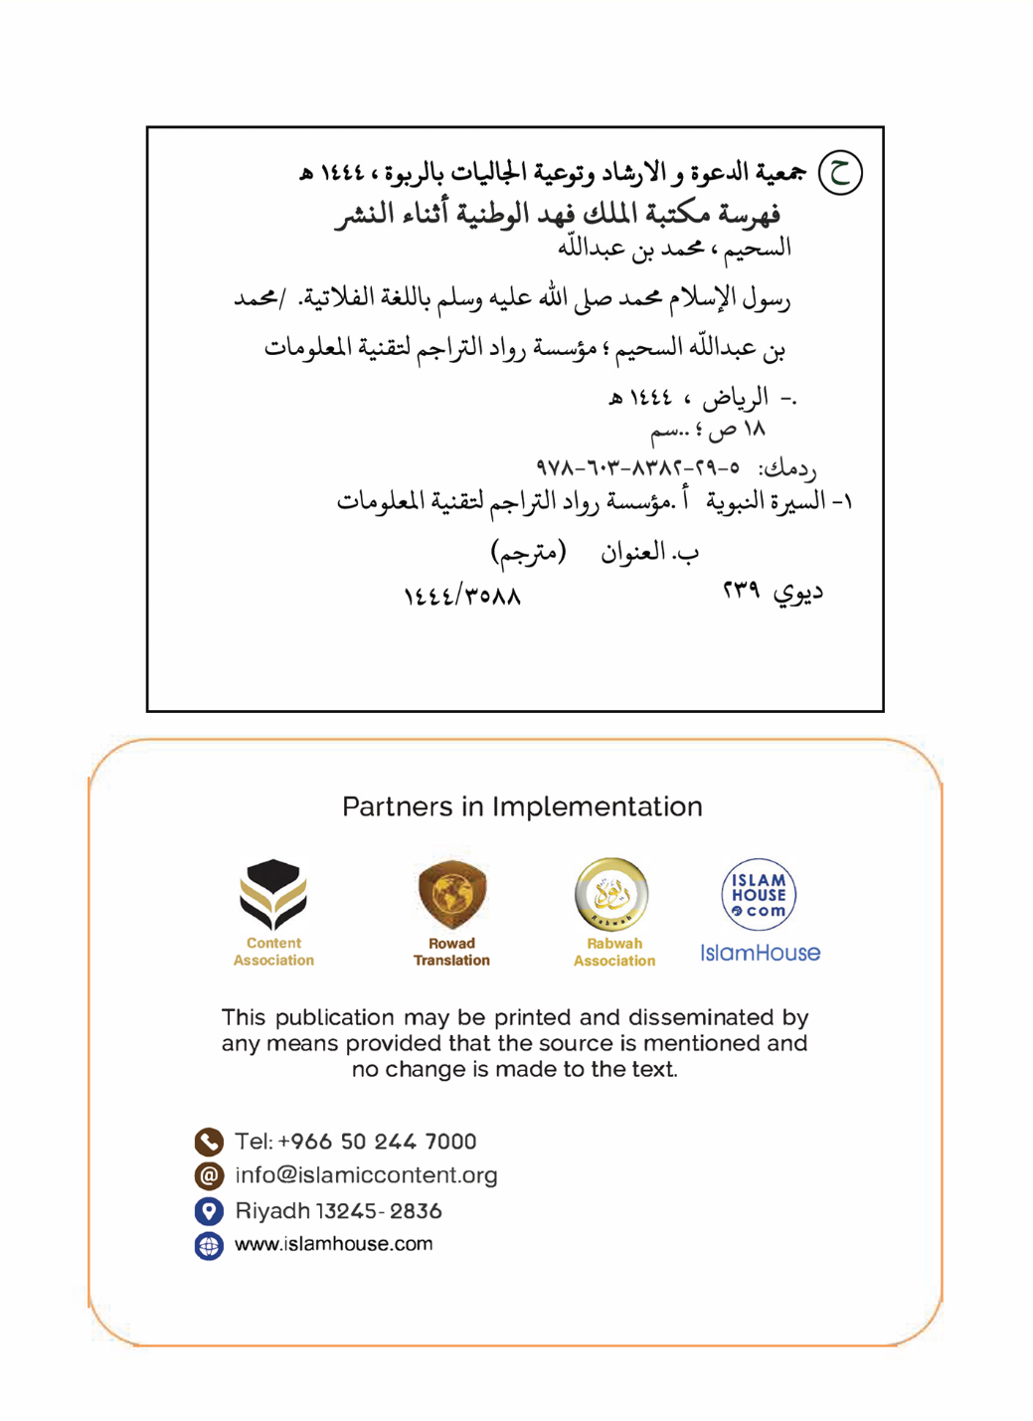

Annabiijo on mo jam e kisiyee woni e mun on.
En puɗɗorii e innnde Alla, kuuɓuɗo yurmeende,keerorɗo yurmeende ka laakara.

Morumuoa oa tumelo ea Islamo Muhammad (khotso le mahlohonolo a Allah li be le eena - KEL).
Huunde setta e Nulaaɗo islaam Muhamadu-1- yo jam e kisal won e makko, mi hollira heen Innde makko, asko,leydi, dewgal, e nelal, e ko o noddi faade mum, e maandeeji annabaagal makko e sariya makko, e darnde haɓdiiɓe makko.

1- Innde makko e asko e saare nde o jibina e ɗo o mawni ɗo.
Nelaaɗo islaam woni Muhamadu Bun Abdullaahi Bun Abdul Muɗalibi Bun Haasim ummiiɗo e mbootu Ismaa*
iil Bun Ibraahiim yo kisal won e ma66e.Waɗi noon ko Annabi Ibraahiima ummiima Saam o ari Makka hombo won di e cuddiiɗo mum Haajara e ɓiyiiko Ismaa*iil, ndeen hombo woni e tiggu,
o hoɗniɓe Makka e yamiroore Alla, nde suka o yottii cagataagal Ibraahiima yo o his ari Makka,kamko e ɓiy makko ɓe mahi Kaaba Suudu Alla hormaandu ndu, yimɓe ɓe keewi e sara mayru,Makka wonti faandorde rewooɓe jom binnde, reerɗuɓe hajjude, yimɓe ɓe njokki rewde Alla e bajjinde Mbo e dow laawol Ibraahiima -yo o his-jiirɗeele keewɗe.
Caggal ɗuum yimɓe ɓe mbaylii, duunde arab nde e o saango na nanndi e leyɗe aduna o fof,
geɗe wasaniyankaagal ɓanngii e oon yonto: rewde sanamuuji, ubbude sukaaɓe rewɓe tawa na nguuri e jaggitde rewɓe e haalde fenaande,
e yarde sanngara e waɗde paŋkare, e ñaamde jawdi alyatiime e nanngude ribaa...
E o nokku e o neesu jibina Nelaaɗo islaam Muhamadu ɓiy Abdullaahi ummiiɗo e mbootu Ismaa*iil ɓiy Ibraahiima yo kisal won e mum,
hitaande 571 J I. baaba makko maayi ko adii jibineede mbo, yummo mum maayii hombo yaara e duuɓi jeegom, bappa makko Abuu Taalib nehi mbo, o wuuri baasɗo alyatimeejo, hombo faggitnoo ko wuurdi.

2- Dewgal barkingal e soknaajo barkiɗo.
Nde duuɓi mum njottii 25 o resi soknaajo jeyaaɗo makka, oon woni Khadiija ɓiy Khuwaylid yo weluya Alla won e makko, ɓe keɓdi ɓiɓɓe naya rewɓe, ɓiɓɓe worɓe ɓe maayiri gila cukaagu, hombo gollindiratno e soknaajo mum e ɓesngu mum e newaare e gilli, ko ɗum saabii soknaajo makko Khadiija na yiɗnoo mbo sanne, kamko ne o yiɗi mbo, o yejjitaani mbo caggal maayde makko duuɓi juutɗi, hombo hirsatno dammuwol ngam sakkanaade Khadiija o feccangol yimɓe sabu teddinde mbo e reen de gilli makko.

3- Fuɗɗaade wahyu.
Nelaaɗo na joginoo jikku tedduɗo gila nde Alla tagi mbo, yimɓe makko na inniratnoo mbo goonɗuɗo koolaaɗo, hombo rentatnoo e mum en golle tedduɗe, homb salinoo koɓe ngonnoo ko e piiji wasaniyankooji, o rennndataana e mum en e ɗuum.
Nde o heɓi capanɗe nay hitaande hombo to Makka Alla suɓii mbo won de Nelaaɗo, Maleyka Jibriil ardi e makko e arwannde simoore adiinde tellaade e alquraana, ɗuum ko konngol Alla Toowɗo o:
﴿ٱقۡرَأۡ بِٱسۡمِ رَبِّكَ ٱلَّذِي خَلَقَ١ خَلَقَ ٱلۡإِنسَٰنَ مِنۡ عَلَقٍ٢ ٱقۡرَأۡ وَرَبُّكَ ٱلۡأَكۡرَمُ٣ ٱلَّذِي عَلَّمَ بِٱلۡقَلَمِ٤ عَلَّمَ ٱلۡإِنسَٰنَ مَا لَمۡ يَعۡلَمۡ٥﴾ [العلق: 1-5]
"Janngu e innde Joom ma, Oon takɗo-1-Tagirɗo neɗɗo e heɗɗere 2 Janngu e Joom ma ɓurɗo teddue 3 Oon ganndanirɗo kuɗol 4. O anndini neɗɗo ko o anndaana 5." Simoore [Alaq 1-5.]
O ari e soknaajo makko ɓernde mum na sinynya, O siimtani mbo kabaaru o lelni fittaandu makko, o yaadi e mum to ɓiy bappa makko Waraqata Ibnu Nawfal- o ko annasra o wonno o janngi Tawraata e Injiil- Khadiija wii mbo nan e ɓiy musiɗɗo ma, Waraqa wi*i mbo: Aan ɓiy musiddo am ko njii ɗa? Nelaaɗo haalani mbo ko yii ko, Waraqa wii mbo:O Naamuus woni mbo Alla tellinno e Muusa,haaniina mi wona tiiɗɗo, haaniina mi wona guurɗo nde yimɓe ma ɓe njaltinatma,Nulaaɗo mo jam e kisal ngoni maaki:Mbele maɓe njaltinam? o wii:eey gorko feera addude ko ngadduɗa ko si wona o anye, si yonta ma tawii mbiɗa wuuri mami wallu ma ballugol cemmbungal-2-.
alquraana jokki tellaade e makko, ko Jibriil tellinatnoo mbo ummaade e Jom binnde, hono nombo ardi e makko e mbaadi pencitaandi.
O jokki hombo nodda faade e islaam, yimɓe makko kaɓii mbo ɓe ndukdi e mum, ɓe kollii mbo jawdi e laamu ngam o acca nelal makko ngal o salii, ɓe mbii hono na yimɓe adiiɓe mbiino nelaaɓe : biloojo, penoowo pekindatooɗo, ɓe ɓittani mbo, ɓe njaggiti mbo e ɓanndu makko teddundu ndu, ɓe tampini wondiiɓe makko.Nelaaodo jokki to makka to noddude faade e Alla, o hucca to yontaaji hajju, e jeereeji luuma aarabooɓe, o hawra e aade en o hollaɓe islaam, o feera faaleede aduna wolla heynaade, o faayniraani silaama, o alaana semmbe wolla laamu, o holli dikkaade e arwannde noddaandu mum ndeɓe ngaddata hono alquraana mbo o addi o, o jokki ngool dikkagol, goonɗini mbo yogo e sahabaaɓe tedduɓe, yo Alla weleɓe kamɓe fof.
To makka to Alla teddiniri mbo kaawis mawɗo o, oon woni setaraade jemma faade Bayti Maqdis, refti o fayi to kammu, na annda noon Alla ɓamtiina Annabi Ilyaas e Masiihu yoɓe kis faade kammu, hono ɗum haalda e ummorde e juulɓe e nasaarara en.Annabi o heɓi yamiroore ummiinde ka Alla yo o juul to kammu to, ko ndeen woni juulde nde juulɓe njuulata hannde laabi joy nder nallal, e nder makka kadi kaawis seekaade lewru waɗi haa heefreɓe nji*i ɗuum.
Heefereeɓe Quraysi mbaɗi huunde kala ngam faddaade mbo, hono hebbin de hodooji e doknude yimɓe ɓe Nelaaɗo, ɓe canndalina e ɗaɓɓude kaawisaaji, ɓe mballitori yahuudu en ngam mballaɓe e hujjaaji ballooji ɓe yeddandirde e makko e falaade yimɓe e makko.
Nde ɓitttre Heeferɓe Quraysi en njokki e dow juulɓe he,Nelaaɗo sakkitiɓe ferde faade habasa,o wiiɓe na toon laamɗo nuunɗuɗo hay gooto toonyetaake to makko,ko o laamɗo nasraaniyanke o wonnoo. pelle ɗiɗe perani toon,ndeɓe njottii Habasa ɓe kolli mbo diine mbo Muhamadu addi o,o wii: wollaahi ko o diine Muusa addi yo o his,ko e bata gooto mbo itta,yimɓe makko lori mbo kamko e wondiiɓe makko.
Ina jeyano e goonɗinɓe e oon yonto he,umminooɓe Madiina ɓe njeeyandiri e makko islaam e wallude mbo si oon eggii faade saare mum en, honde wiyeteno Yasriba, o sakkiti heddinooɓe makka ferde faade madiina Annabiyanke nde, ɓe peri islaam sarii nder Madiina, haa alaana toon suudu ndu islaam naataani.
Caggal nde Nelaaɗo woni Makko kitaale sappa e tati hombo nodda faade e Alla, Alla sakkiti mbo yo o fer faade Madiina,Nelaaɗo feri,o jokki noddude faade e Alla,tellagol sariya ngol jokkondiri huunde huunde,o fuɗɗii nelde nelaaɓe makko roondiiɓe ɓatakeeji faade e hooreeɓe leyɗe e leyyi ɓe noddaɓe faade e islaam,ina jeya ɓe o nelatno faade e mum en laamɗo Ruum e laamɗo Faaris e laamɗo Misra.
To madiina to seeda toon nanngeede naange yimɓe ɓe paayi, ɗuum hawri e maayde Ibraahiima ɓiy Annabi yo jam e kisal won e mum, yimɓe ɓe mbii: naange naggaama ngam maayde Ibraahiima, Annabi o maaki:Pellet naange e lewru jaggetaake sabu maayde hay gooto, wona sabu nguurndam hay gooto, kono kodi e kaawisaaji Ala, Alla na hulɓnirta jiyaabe Makko -3-Si Nelaaɗo wonno penoowo ma o yaawnatono O hulɓina yimɓe fennude mbo o maaka won de naange jagga ngam maayde Ibraahiima, hono pennuɗomi alhaali mum wonirta.
Nelaaɗo yo jam e kisal won e mum, Joom makko yooɗnirii mbo jikkuuji timmuɗi, Alla sifarii mbo e konngol makko:
﴿وَإِنَّكَ لَعَلَىٰ خُلُقٍ عَظِيمٖ٤﴾ [القلم: 4]
"Aan haɗa woni e dow jukku tedduɗo". Simoore [Qalam -4-]
Hombo wonno cifariiɗo e kala jikku labaaɗo hono goonɗude e laaɓde reedu, e jaambaraagal e nuunɗal e huuɓnude aadi won duɓe e haɓdiiɗe, e teddungal, hombo yiɗno sakkaade waasɗe e miskineeɓe e maayraaɓe jom galle mum en, e hatajinɓe e reerɗude e feewnudeɓe, e yurmaade ɓe e yankinanaade ɓe, haa si tumaranke ariina hombo yiilo nelaaɗo, o anndidtaana nelaaɗo e won diiɓe mum, o wiya hombo e mon woni Muhamadu?
Daartol makko wonnoo ko timmal e teddungal wonan de ɓe o ngollidata fof, foti ko giɗo maa mbo wona giɗo, foti ko ɓadiiɗo maa ko goɗɗuɗo, mawɗo wollo suko, debbo wollo gorko, kullel wolla ndiwri.
nde Alla timminani mbo diine, kamko ne o yottini mbo kaaɗdi jottingol, o maayi hombo yaara e duuɓe capanɗe jeegom e tati hitaande, heen capanɗe nay ko adii nde o nelate, noogaas e tati hitaande hombo woni annabi nelaaɗo.O wirnaa to madiina- yo o his- o accaani jawdi wona ko ronate, si wona mbaba puccu daneejo mbo o waɗɗatono o, e leydi ndi o acciri sadak wonnan de ɓiɓɓe laawol.
Goonɗinnooɓe ɓe njebbalii ndewi e makko na keewno sanne,hajjidi e makko e hajju bayngal ko ɓuri teemedere ujunere,ɗuum wonno ko adii maayde mo hedde lebbi tati,na gasa ɗum na jeya e ko reeni diine makko e saraade mbo,Sahabaaɓe makko ɓe o neeno e jikkuuji islaam na njeyano e ɓurɓe labeede nuunɗal e ruuɗaade aduna e huuɓnude aadii e yarlitanaade o diine teddɗo mbo ɓe goonɗini o.
Wonndiiɓe makko ɓurnooɓe teddude fof en to bannge iimaan e ganndal e golle, e laaɓde reedu e goonɗinde yarlitaade e cuusal e teddungal ko : Abuu bakri e Umar ɓey Khattaab e Usmaan ɓiy Affaan e Aliyyu ɓiy Abii Taalib, yo weluya Alla won e mum en, Ko ɓe njeyanoo e adiiɓe ja6de de mbo, ko kam6e ngonno lomtiiɓe caggal makko, ɓe ngalaana hay huunde e ko heerori annabaagal, nelaaɗo heertinaani ɓe huunde gaa e sahabaaɓe woɓɓee ɓe, yo weluya Alla won e mum en.
Alla reeniri deftere makko nde o addi nde e sunna makko, e daartol makko e konngi makko e golle makko ko e ɗemngal makko ngal o haaldatno, daartol feerah reeneede- e nder taariik- hono no daarol nelaaɗo mo jam e kisal ngoni e mum reenira nih, ngol reeni hono o ɗaanorotono e no naamratno e no yardatno e no jaldatno.Hono o gollondiratno e yimɓe galle makko nder galle mum?Kala alhaaliiji makko na ndeena na mbinnda e nder daartol makko he, kamko ko o ɓannduyanke nelaaɗo o alah hay huunde ko Alla heerori,o joganaaki hoore makko nafoore wollo lorro si wonah ko Alla haaji.

4- Nelal makko.
Alla nelii Muamadu yo o his caggal de sirku e keefaraagu e majjere kuuɓtadini aduna o fof, oon tuma alaana dewoowo Alla e dow leydi tawa renndintah mbo e goɗɗum, tawi wonah kedde setta e yimɓe joom en defte, Alla neli Muhamdu yo o won timmoode nelaaɓe e annabaaɓe, Alla neldi mbo peewal e diine goonga wonan de winndere nde, haa mbo heeda dow diineeji fof, haa o yaltina aade en e niɓe sanamaagal e keefraagu e majjere faade e annoore tawhiid e iimaan, nelal mum ngal ko ngam timmin de nele annabaaɓe adiiɓe ɓe, yo jam e kisal won e maɓɓe.
O noddi ko annabaaɓe e nelaabeɓe fof noddatno faade e mum yo jam e kisal won e mum en: Nuuhu e Ibraahiima e Muusa e Suleymaan e Daawuuda e Iiisa- faade e iimaan won de ko Joomiraawo woni Alla takɗo garsakinɗo baroowo jeyɗo laamu, ko kamko yiilata fiyaaku , newiiɗo jurmotooɗo, ko Alla woni takdo kala ko wo ni e winndere he, ko seedete e ko seedetaake, kala ko wona Alla ko ka taga tee jeyaa ko e tagoore makko he.
Hono o noddiri faade e rewde Alla tan e accude mbo wona kanko, o holli wonde Alla ko gooto mbo alah denndadiijo e reweede e laamu e tagoore mum e jiilgol fiyakuuji makko, o holli kadi won de Alla jibinaani o jibinaako, o alah pasa wollo nandadiijo, O tellataako e huunde o ɓanndinataako e majjum.
O noddi e gumde defte Alliyankooje gadiiɗe ɗe hono ɗeri Ibraahiima e Muusa yo kisal won e mum en,e Tawreeta e Jabuura e Injiila, hono o noddiri goonɗinde nelaaɓe ɓe fof, teskaama won de kala pennuɗo gooto e maɓɓe o yeddiiɓe kamɓe fof.
O weltaniri aade en fof yurmeende Alla, won de ko Alla fawii ko yonataɓe e aduna, ko Alla woni jurmotooɗo Joomiraaɗo, ko Kamko tan haasbata tagoore nde nyande darngo, nde O umminiɓe e genaale mum en, ko kamko yoɓata juulɓe golle mum en lobbe golluɗo gootel yoɓe sappo, mbo golli ko boni yoɓe yeru mum, woodanii juulɓe ɓe dokkeAlla duumiiɗe to laakara, oon jedduɗo heɓa njoɓdi mum aduna e laakara.
Nelaaɗo tedduɓɗo o e nulal mum he, o mantaani o mawnina lenyol mum wollo leydi wolla fittaandu mum teddundu ndu e dow goɗɗo, ko woni ko jolii e alquraana tedduɗo jantaade inɗe annabaaɓe hono Nuuhu, Ibraahiima, Muusa e Iisa yoo kisal won e mum en ko ɓuri ko Innde makko ari e alquraana, halaaka innde neene makko wonah inɗe suddiiɓe makko e nder alquraana tedduɗo o, kono tan innde yumma Muusa haalaaama e alquraana ko wonah laawol gootol, Innde Mariyama kadi joli(e alquraana) ko wonata capantati e joy laawol e nder alquraana.
Nelaaɗo Muhamadu- yo ohis- ko deenaaɗo e kala goopol lunndingol sariya wollo hakkille maa neesu wolla boom ko jikku kisɗo salato, Annabaaɓe ko reenaaɓe koɓe yottinta ko ummaade e Alla, sabu ko kamɓe yamira yo yottin jamiraaɗe Alla faade e jiyaaɓe, Annabaaɓe noon ngalah hay huunde ko Alla heerori ko e Alliyankeegu e dewal makko, alah kamɓe de koɓe yimɓe hono denndaangal aade en, kono tan Alla na wahyoo e maɓɓe nele makko ɗe.
Ina jeyaa ko ɓuri mawnude ko ina holla wonde nelal Muhamadu- yo o his- ko wahyu ummiiɗo to Alla ko won de haa jooni hongal woodi, hono no ngal waano saanga wahyu tellato nih, te na rewi ngaal nelal ko ɓuri miliyaar juulɗo, hoɓe ummoo ko sariya fawie ko hono juulde e askal e koorko e hajju eken... tee alah fof ko waylii heen haa jooni.

5- Maandeeji Annabaagal e kaawisaaji mum e dallillaaji mum.
Kaawisaaji e maandeeji na cemmbina Annabaaɓe e annabaagal mum en,ɗuum na darnanaɓe hujjaaji e dallillaaji ceedatooɗi nelal maɓɓe ngal,Alla okki kala Annabi kaawisaaji jonooji yimɓe yonto mum goonɗinde yeru ɗuum, kaawis annabi men Muhahamadu ɓuri mawnude ko woɓɓe ɓee totta ko,ndeen woni alquraana tedduɗo o,ko ɗuum woni kaawis keddotooɗo haa darngo, Alla seemmbinirii mbo kadi kaawisaaji njani,kaawisaaji makko na keewi ina heen:
Roƴde e yaade ka kammu, ɗuum woni ummaade makka jemma yaara jemma haa Baytil Maqdis yawta ka kammu, ina heen kadi feccaade lewru ndu pecce ɗiɗe e tellago toɓo laabi limti limtinɗi caggal de nde nelaaɗo torii Joomi makko nde yimɓe makko njarnete caggal hokkere.
E hebbinde nyaamdu e ndiyam pamɗuɗam haa yimɓe heewɓe kaara heen njara heen.
E habrude geɗe birtiiɗe ɓennuɗe ɗe hay gooto anndaana pencital mum, hon daari annabaaɓe won dude e yimɓe mum en ɗi Alla habriɓe, e daarol ashaabul kahfi ( joman en wimmba).
E habrude geɗe birniiɗe ɗe ciwah arde, baɗɗe caggal nde o habriɗe, hono kabaaru yaltude yiite to Hijaaj, ngeen wonnooɓe Saam nji*iina nge, dannandirde yimɓe ɓe e toowgole kuɓeeje.
E ko Alla yoni mbo ko, e ko Alla reeni mbo ko e yimɓe.
Ko o fodannoo ko sahabaaɓe mum ɓe laati.Pellet maa udditane on Faaris e Ruum, ma on nafqu ngaluuji maɓɓe.
E ko Alla semmbiniri mbo malaykaaji.
E weltanirde annabaaɓe yimɗeɓ maɓɓe annabaagal Muhammadu- yo ohis- ina jeyaa e ɓeen weltanirɓe ɗuum Muusa, Daawuuda, Suleymaan e Iisa yo kisal won e mum en, e ko wonah ɓe jantaaɓe ɗo.
E dallillaaji hakkilleyankooji e yeruuji piyaaɗi-5- ɗi hakkille kisɗo yankinanto.
Dallillaaji e aayeeje hakkilleynkooje na carii e nder alquraana tedduɗo o, e sunna annabi o, ɗeen aayeeje ɗe limataako, ngala faalaaɗo yiide ɗuum yo o rutto e alquraana e defte sunna annabiyanke o, ina e hembo kabaaru pellet e ɗii kaawisaaji.
Kaawisaaji mawdi ɗi si njanaano, ma habdiiɓe makko ummaade e heefereeɓe Quraysi e Yahuudu e Nasaara en heɓayna waawtungo fennude mbo e reentinde yimɓe ɓe gaa makko.alquraana tedduɗo o ko deftere nde Alla wahyii Nelaaɗo Makko Muhammadu,konde haala Jom binnde,O dikkii heen yimɓe e jinneeji ndeɓe ngaddata hono mayre wolla simoore yeru mayre,haa jooni ngool dikkagol na woodi,Quraana na jaabo naamne buy beemnuɗe ko heewi e yimɓe,quraana na reena haa jooni e ɗemngal arab mbo ngal tellori ngal,hay harfeere ustaaki e mammba,hombo muula mbo saraa,konde deftere teddunde ronkinnde fof en,ko kannde ɓuri teddude deftere arnde e yimɓe,honde haani janngeede wolla janngee maanaaji mayre,kala paataraaɗo janngude nde wollo goonɗinde nde o waasi nafoore heewnde.Sunna Nelaaɗo Muhammadu -yo o his- e peewal mum e daartol makko na reenaa na eggaa e callala habrooɓe hoolaaɓe, ɗuum na muula e ɗemngal arab ngal Nelaaɗo haalatno, elle hombo wuurdi e men, mbo fulaama e ɗemɗe keewɗe, alquraana e sunna Annabi ngoni iwdi ngootiri nyaawooje islaam e sariyaaji mum.

6- Sariya mbo Nelaaɗo Muhammadu- yo o his - addii:
Sariya mbo nelaaɗo Muhammadu -yo o his- addi o: woni sariya islaam, kammba timmini sariyaaji Alliyankooji e nele dewateeɗo O, hoɗi njerindiri to bannge asli won dude e sariyaaji annabaaɓe adiiɓe hay si mbaadi mum seerti.
Kammbo woni sariya timmal, hombo yaadi e kala yonta e kala nokku, ina e hembo labegol diine yimɓe aduna mum en, hombo soomi denndaangal dewe pawiiɗe e jiyaaaɓe sabu Alla, hono juulde e askal, hombo hollaɓe gollondire to bannge jawdi e faggudu e renndo e dawrugol e hare e neesu dagiiɗo e kaɗaaɗo e kala ko nafata yimɓe e nguurndam mum en ruttorde maɓɓe.
O diine na reena diineeji yimɓe e ɗiiye, guri, jawle, hakkillaaji e ɓiɓɓe maɓɓe, hombo soomi kala ko laba e ɗiggere, homo reentina kala ko boni, hombo nodda faade e teddungal aade, hakindaade, nuunɗal, laaɓde reedu, laaɓal karallaagal, gilli, yiɗde ko laba wonande aade en, waasde rufde ɗiiyam, hisde koɗorɗe e harminde hulɓinde yimɓe ko aldah e laawol. Nelaaɗo -yo o his- na haɓatonoo bewre e bonnde e kala mbaadi, o yahdaana e jiiki jaaka e follaade e rahbaaniyankaagal.
nelaaɗo Muhamadu holli wonde Alla teddani aade rewɓe e worɓe fof, O defanii mbo hakkeeji mum en, ɓe ngoni naamnitteɓe koɓe cuɓii e golle e baylitale, joom mum roonditoo kadi kala golle lorooje mbo wollo woɓɓe. O waɗi gorko e debbo poti to bannge iimaan e naamniteede e njoɓdi e baraaje, ina nder sariya ko hollat toppitagol debbo foti ko o yummo maa cuddiiɗo wolla ɓiɗɗo waa banndiraawo debbo.
Sariya islaam mnbo nelaaɗo Muhamadu-yo o his- addi o, na reena hakkille e na harmina kala ko bonnata mbo hono yarde sanngara, Islaam teskii diine ko annoore jalbinanatnde hakkillle laawol mum, ngam neɗɗo rewa Joomiiko tawa fawii ko e njiinde e ganndal, islaam toowni tolnde hakkille haa waɗi ɗum ka pawe sariya pawete, mbo rimɗini mbo e tonngi jiiki jaaka e sanamaagal.
Sariya islaam na teddina ganndal cellungal,hombo hirjina e witto ganndal ngo yaadaani e belaade, hombo noddo e ndaarde e miijaade e fittaandu e winndere he,e njencudiiji ganndal celluɗi, luutandir- tah e ko Nelaaɗo addi ko yo o his-.
Alah e nder sariya faltaade lenyol e dow goɗngol, mbo ɓurnaani yimɓe e dow woɗɓe, fof en na pota e yeesa nyaawooje makko, sabu yimɓe fof jiidi iwdi, alah ɓurɗo goɗɗo si wonah kulol Alla, nelaaɗo habrii wonde kala jibinaaɗo jibintee ko e neesu, alah jibidinteeɗo e goopol wolla rona goopol e goɗɗo.
E sariya islaam Alla sariyini tuubde ɗuum woni: ruttaade neɗɗo faade e Joom makko e accude bakkatuuji, islam na yirbina bakkatuuji gadiiɗi, tuubuubuya na momta bakkatuuji gadiiɗi, aade haajaraani qirraade e yeeso goɗɗo goopi makko, sabu jotondiral hakkunde neɗɗo e Joomiiko alah heeda, hatajinaani nde goɗɗo wonata hakkunde maɓɓe, islaam na haɗa nde mbaɗaten yimɓe Alla ma rennduɓe e Alla e alliyankaagal wolla e dewal makko.
Sariya mbo Muammadu-yo o his- addi o ko momtuɗo sariyaaji gadiiɗi ɗi, sabu ko kammbo woni mbo muhamadu -yo o his- addi ka All, ko kammba sakkitii haa darngo, ko yimɓe fof mbo arani, ɗuum saabi mbo momti gadiiɗi ɗi, Alla jaɓatah sariya goɗɗo mbo wonah islaam, O jaɓah kadi diine goɗɗo mbo wonah islaam mbo nelaaɗo addi o, kala piɓɗo ko wonah diine islaam o jaɓanetaake, kala paalaaɗo anndude pencitale sariya islaam yo o ɗaɓɓu ɗum e defte koolaaɗe tinndinooje islaam.
Woni faandaare sariya islaam-hono no woniri faandaare denndaangal nele Alliyankooje- konde diine goongo toownata aade o wona maccuɗo Alla laaɓtudo, o rimda e won de maccudo neɗɗo wollo jawdi wollo jiiki jaaka.
Sariya islaam o na yaadi e kala yonto e kala nokku, alah e mammba kono luutandira e maslahaaji aade, sabu ko ka Alla mbo tellarii gannduɗo O ko aade haajori, aade en na kaajori e sariya celludo e hoore makko, mbo yogo e mum firtatah yogo goo, cellinoowo aade en fof, wonah mbo yogo e aade lelnata, ɓe poti heɓde mbo ko ummaade e Alla, mbo feewna yimɓe ɓe e laawol jam e peewal, si wonii ɓe nyaawrii mbo fiyakuuji mum en poocco, ɓe kisa e toonyondirde.

7- Darnde haɓdiiɓe makko e mum e koɓe ceedanii mbo.
Sikke alah won de kala Annabi na jogii haɓdiibe na kaɓoo mbo na ndaro e laawol noddaandu makko, ɓe palooɓe gaa e goonɗinde mbo, nelaaɗo Alla Muhamadu yo o his, na joginoo haɓdiiɓe heewɓe e nguurndam mum e caggal nde o maayi, kono tan Alla walli mbo e dow maɓɓe,heewɓe e mabbe seedeeji mum en ndewandirii won de ko o annabi, te addi ko annabaaɓe ko annabaabe adiiɓe gadduno ko, hoɓe nganndi ko e goongo o woni, kono tan geɗe keewɗe na kaɗa heewɓe e maɓɓe goonɗinde sabu yiɗde laamu maa hulde renndo wolla pertude jawdi ndi o faggato e palaas mum he.
Yettoore woodanii Alla, Jeyɗo Winndere nden.
ko dr Muhamed Abdu Sahiim winndi nde.
Porofisoor fiɓnde to bannge wittooji Islaam (ko adii)
Duɗal Jaaɓi haattirde Uniwersite Malik Sa*uud.
Riyad laamaandi Arabi Sa*uudi.

Contents
Morumuoa oa tumelo ea Islamo Muhammad (khotso le mahlohonolo a Allah li be le eena - KEL). 4
1- Innde makko e asko e saare nde o jibina e ɗo o mawni ɗo. 4
2- Dewgal barkingal e soknaajo barkiɗo. 6
3- Fuɗɗaade wahyu. 6
4- Nelal makko. 14
5- Maandeeji Annabaagal e kaawisaaji mum e dallillaaji mum. 17
6- Sariya mbo Nelaaɗo Muhammadu- yo o his - addii: 20
7- Darnde haɓdiiɓe makko e mum e koɓe ceedanii mbo. 24
Contents 26

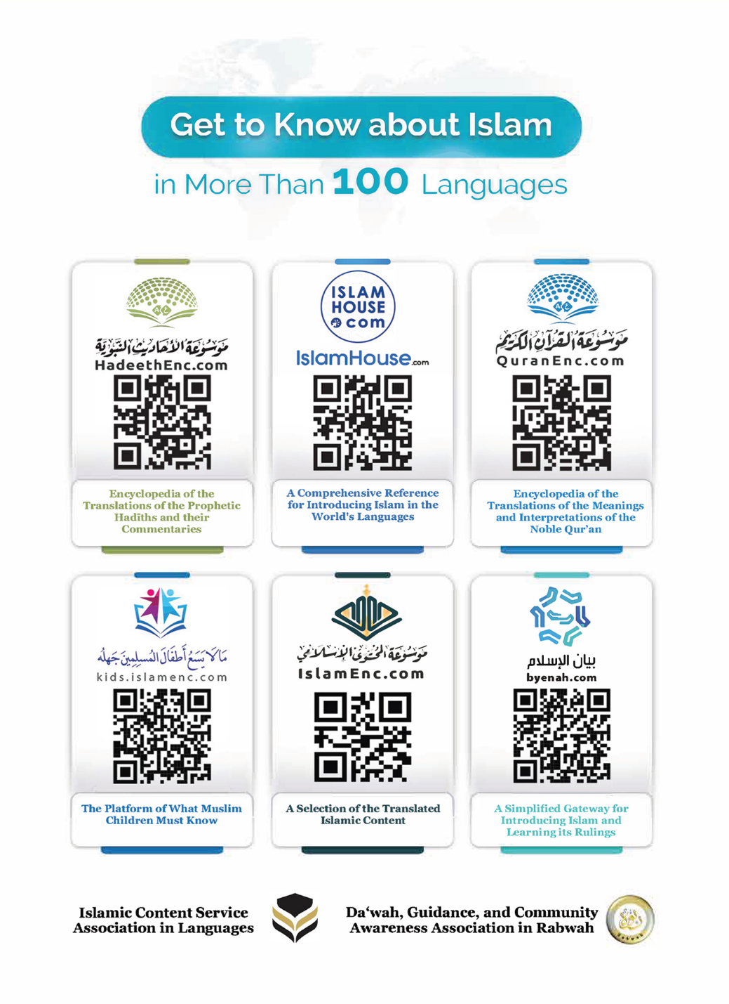
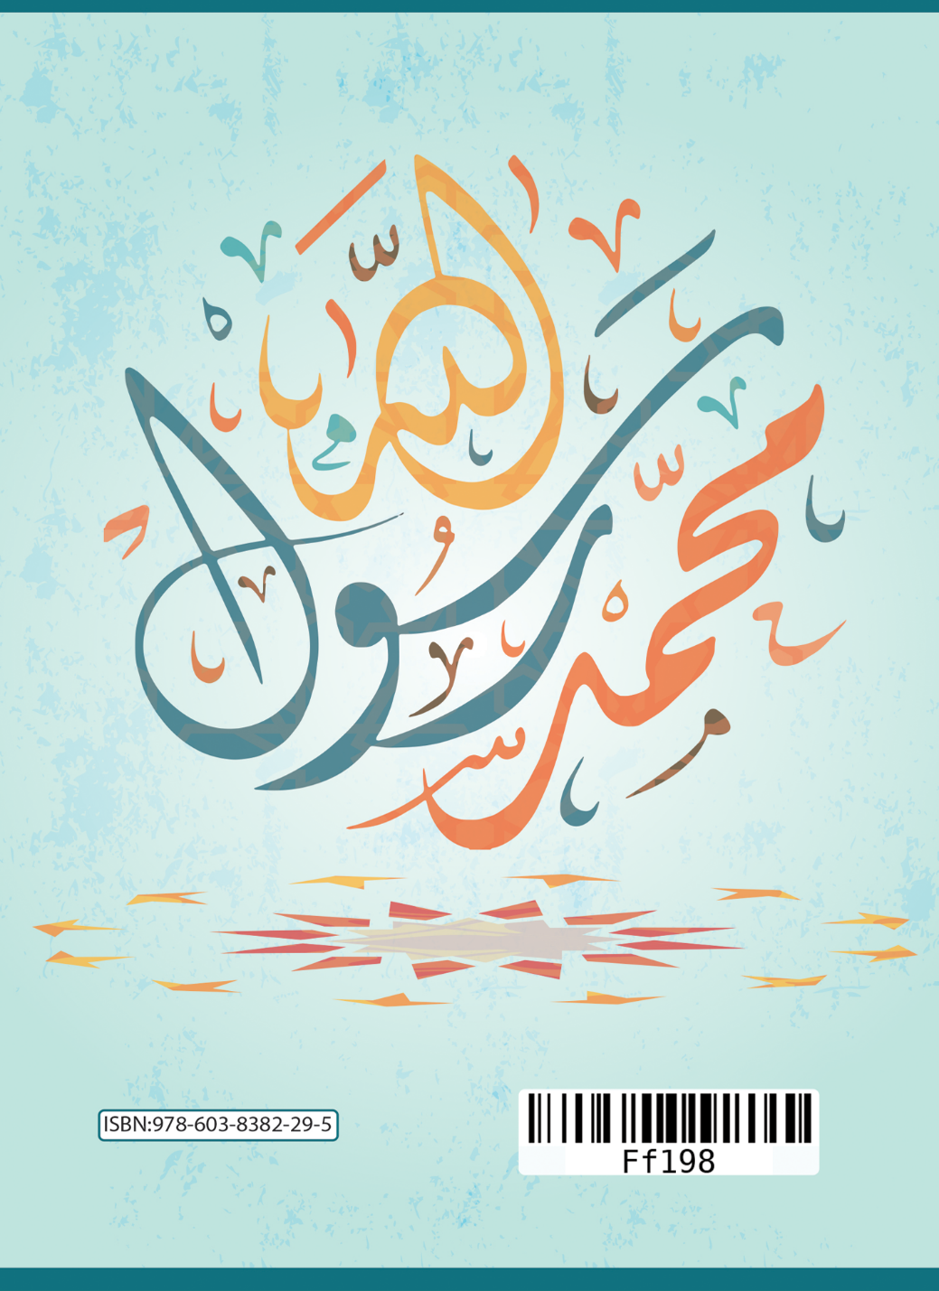

Mina reerɗi nde cinndandirat mi hakkunde konnguɗi ɗiɗi ɗiin ngoni : Nulaaɗo e Muhamadu ngam reen de fula deftere nde, ndaaron ɗuum.
O hadiis Aa*isa ko kawraaɗo e mum, e Sahiih Bukari-2- 1/7 e Sahiih Muslim -152- 1/139.
Sahiih Muslim -901-
Sahiih Bukaari -4461-15¨/6.
Hono konngol Alla toowɗo o: ( eehey mon yimɓe misaal fiyaama keɗee mbo, ɓeen ɓe noddaton ko wonah Alla ɓe tagatah mbuubu haysi ɓe kawrinii ɗum, si mbuubu teetanii ɓe huunde ɓe ndanndataa ɗum e mammba, lohii ɗaɓɓuɗo e ɗaɓɓaaɗo. Al Hajji 73.

