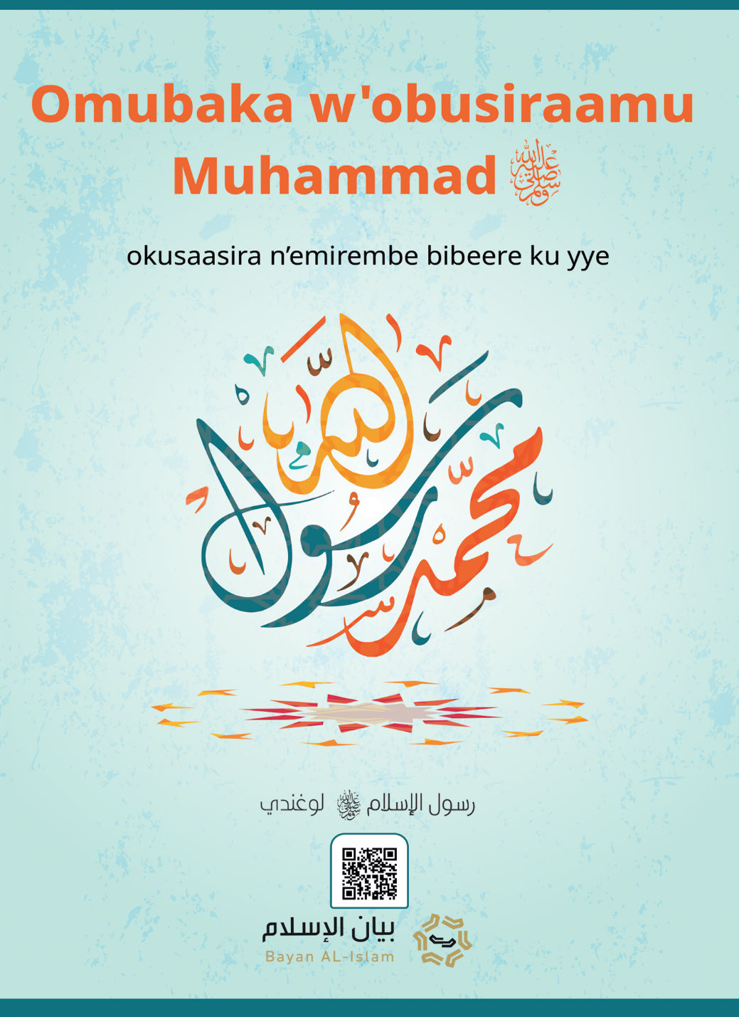

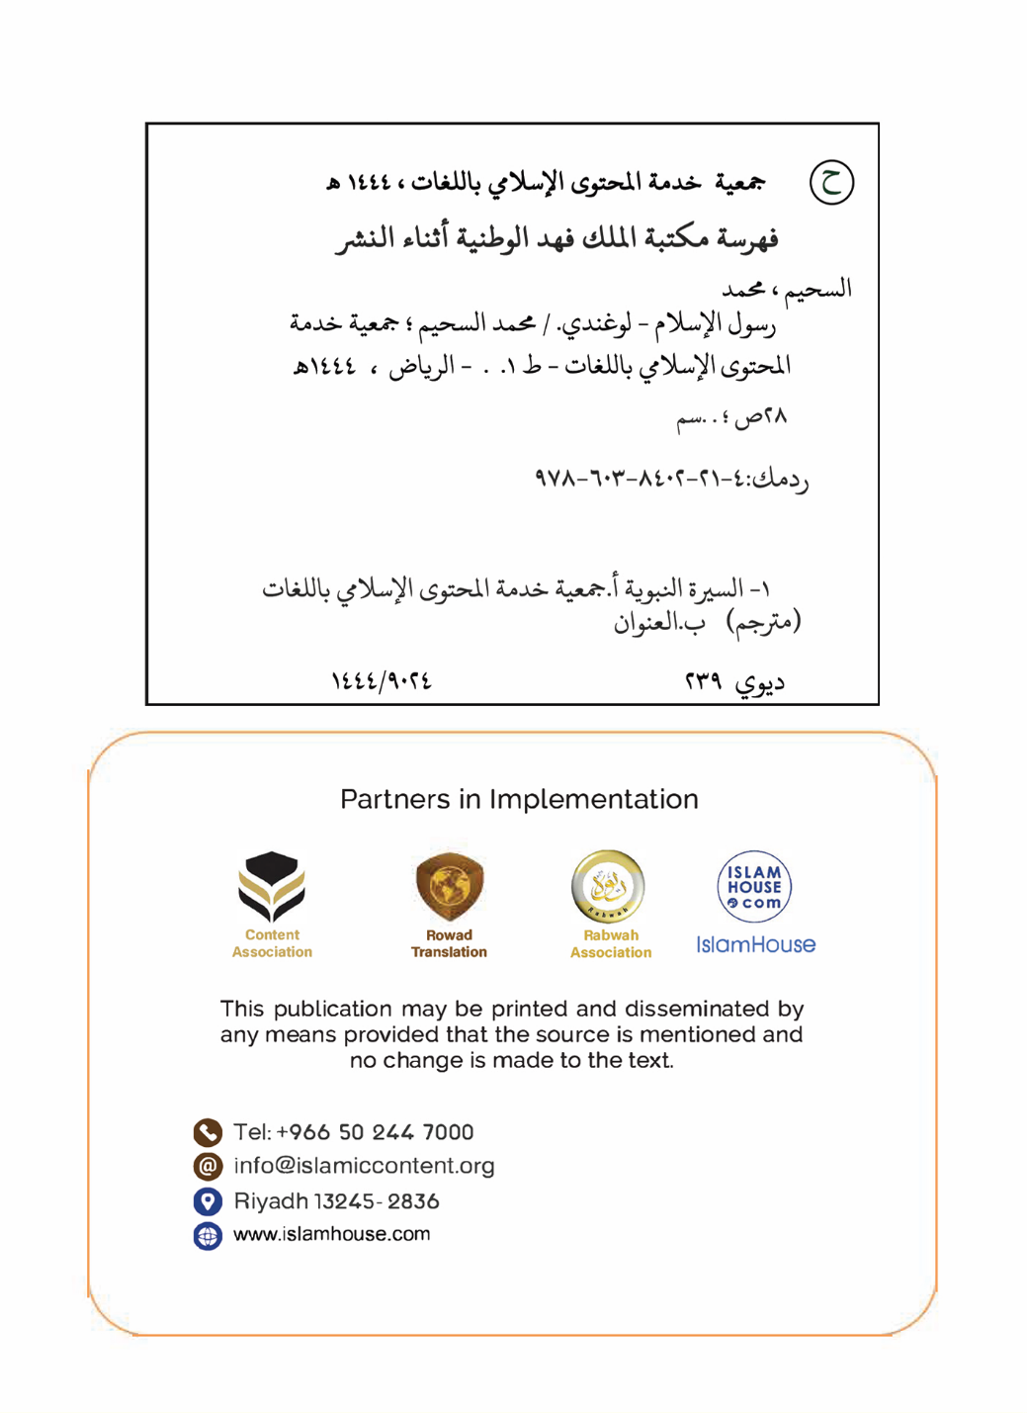

Omubaka w'obusiraamu Muhammad okusaasira n’emirembe bibeere ku yye

Kulw'erinnya lya Allah Omusaasizi ennyo ow'ekisa ekingi

Omubaka w'obusiraamu Muhammad okusaasira n’emirembe bibeere ku yye
Ebitonotono mubufunze ebikwatagana ku mubaka w’obusiraamu Muhammad-okusaasira n’emirembe bibeere ku yye- , nyinyonnyola mu byo erinnya lye n’ekika kye n’eggwanga lye n’okuwasa kwe, n’obubaka bwe, n’ekyo kyeyakoowoola okudda gye kiri, n'obubonero obulaga obwa nnabbi bwe, ne ssemateeka we, n’okulaga abamuwakanya webayimiridde ku yye.

1- Erinnya lye n'ekika kye n'ekitundu mweyazaalibwa ne mweyakulira
Omubaka w'obusiraamu ye Muhammad mutabani wa Abdallah mutabani wa Abdulmuttwalib mutabani wa Haashim omu ku baana ba Ismail mutabani wa Ibrahim emirembe gibeere ku bonna. era ekyo kiri bwekityo kubanga mazima nnabbi Ibrahim -emirembe gibeere ku yye- yava e shaami okudda e makka, nga ali ne mukyala we Haajara n’omwana we Ismail, nga akyali mu kibaya, n’abateeka mu makka nga akolera ku kiragiro okuva eri Allah owekitiibwa era owa waggulu, omulenzi bweyavubuka, nnabbi Ibrahim -emirembe gibeere ku yye- yajja e makka, n’azimba yye ne mutabani we Ismail -emirembe gibeere ku bombiriri- “kaaba” ennyumba ey'emizizo, abantu ne bayinjiwala okwetoolola ennyumba, makka n’efuuka nga yeeyettanirwa abasinza Allah omulezi w'ebitonde byonna, abo abaagala okukola hijja(okulamaga), abantu ne bagenda mu maaso n’okusinza Allah n’okumwawula [mu bw’omu bwe] ku nzikiriza ya Ibrahim -emirembe gibeere ku yye- ebyasa, oluvannyuma newabaawo okukyuka (okuva kw'eyo enzikiriza), embeera y’ekyondo kya buwalabu n'ebeera nga yeemu ne y’ebikyetoolodde mu mawanga g’ensi, nga ebintu by’obusamize byeyolese mu kyo: nga okusinza ebibumbe, n’okuziika abawala, n’okulyazaamaanya abakyala, n’okuwa obujulizi obw’obulimba, n’okunywa omwenge, n’okwebagala ebyobukaba, n’okulya ebyobugagga bya bamulekwa n’okulya enfissi (riba) … mu kifo ekyo era mu mbeera eyo yazaalibwa omubaka w’obusiraamu Muhammad mutabani wa Abdallah okuva mu lunyiriri lwa Ismail mutabani wa Ibrahim -emirembe gibeere ku bonna-, mu mwaka gwa 571 [mu mbala y’emyaka gy’oluzungu (Gregorian)], taata we yafa nga tannazaalibwa, ate ne maama we n’afa nga alina emyaka mukaaga, taata we omuto Abu Twalib n’amulabirira, n’awangaala nga mulekwa, mwavu, era okulya kwe n’ebyenfuna bye yabiggya nga mu kwekolerera na mikono gye.

2- Okuwasa okw'emikisa eri omukyala ow'emikisa
Bweyaweza emyaka abiri mwetaano yawasa omukyala ow’ekitiibwa mu bakyala be makka era nga ye Khadiija muwala wa Khuwaylid -Allah amusiime-, era n'amugabirirwamu [ekirabo ky'] abawala bana n’abalenzi babiri, batabani be ne bafa mu buto bwabwe bombiririne, era enkolagana ye ne mukyala we n’abo mu nju ye yali ku ntikko y’obukwatampola n’omukwano, era y’ensonga eyamwagazisa mukyala we Khadiija olwagala olwamaanyi, era naye nnabbi bwatyo n’amwagala (nnyo), era nnabbi teyamwerabira n’oluvannyuma lw’emyaka emingi nga afudde, era yasala nga endiga n’agigabula ab’emikwano ba Khadiija -Allah amusiime- olw’okubagulumiza, olw[‘okwongera okulaga] okuyisa obulungi Khadiija n’okukuuma omukwano gwe jaali.

3- Entandikwa y'obubaka
Yali omubaka Muhammad -okusaasira n’emirembe bibeere ku yye- wa mpisa nnungi nnyo okuva Allah lwe yamutonda, era abantu be baamuyita nga: ow’amazima omwesigwa, era yali nga yeetaba wamu nabo mu mirimu egy’ekitiibwa, era nga atamwa enkola yaabwe ey’okusinza ebibumbe era nga teyeetaba nabo mu byo.
era bweyaweza emyaka amakumi ana nga ali mu Makka, Allah yamulonda okubeera omubaka, bw'atyo najjirwa malayika Jibriil -emirembe gibeere ku yyo- ku ntandikwa y'essuula eyasooka okukka mu Qur'an era nga bye bigambo bye [Allah] owa waggulu [ebigamba nti]:
﴿ٱقۡرَأۡ بِٱسۡمِ رَبِّكَ ٱلَّذِي خَلَقَ١ خَلَقَ ٱلۡإِنسَٰنَ مِنۡ عَلَقٍ٢ ٱقۡرَأۡ وَرَبُّكَ ٱلۡأَكۡرَمُ٣ ٱلَّذِي عَلَّمَ بِٱلۡقَلَمِ٤ عَلَّمَ ٱلۡإِنسَٰنَ مَا لَمۡ يَعۡلَمۡ٥﴾[العلق: 1-5]
{Soma ku lw'erinnya lya mukama wo oyo eyatonda (buli kintu). (1) Yatonda omuntu nga amuggya mu kisaayisaayi. (2) Soma, kuba Omulezi wo (Katonda) ye mugabi asinga. (3) Oyo eyayigiriza omuntu n'ekkalaamu.(4) Yayigiriza omuntu ebyo bye yali tamanyi. (5)) [Suuratul Alaq: 1-5],
najja eri mukyala we Khadiija -Allah amusiime- nga omutima gwe gukankana, n’amunyumiza amawulire, [Khadiija] n’amugumya, era n’amutwala eri mutabani wa taata we omuto Waraqat mutabani wa Nawfal -ate nga yali yayingira obukulisitaayo era n’asoma Tawraati ne Injil-, Khadiija n’amugamba: owange mutabani wa taata omuto, wuliriza mutabani wa muganda wo, Waraqat n’amugamba: owange mutabani wa muganda wange kiki ky’olaba? Omubaka wa Allah -okusaasira n’emirembe bibeere ku yye- n’amubuulira amawulire g’ebyo bye yalaba, Waraqat n’amugamba: (eyo ye Naamuus [malayika Jibriil] Allah gweyassa ku Musa, nneegomba ssinga mbaddemu ku maanyi, nneegomba ssinga mba mulamu mu kiseera abantu bo bwenaba bakugobaganya, ky’ava agamba omubaka wa Allah -okusaasira n’emirembe bibeere ku yye- : “bbo bennyini bebagenda okunneegobaganyiza?”, n’agamba: iyye, tewali muntu yenna eyajja n’ebifaanagana ne by’ozze nabyo okujjako nga yayigganyizibwa, olunaku lwo bwelunansangawo nja kukutaasa olutaasa olwamaanyi).
era mu Makka Qur'an y'eyongera okumukkako, nga Jibriil – emirembe gibeere ku yye- akka nayo okuva eri omulezi w’ebitonde ng'era bweyamujjiranga n’obubaka obulambulukufu.
yagenda mu maaso n’okukoowola abantu be okujja eri obusiraamu, abantu ne bamwesamba era ne bamulwanyisa, era nebabaako byebamwanjulira (okumuwa singa) alekewo ensonga y’obubaka: emmaali n’obuyinza, era byonna n’abigaana, ne bamuyita nga abantu byebaayita nga ababaka abamusooka: mulogo, mulimba, mujwetesi, era ne bamunyigiriza, era ne bamukolako obulumbaganyi ku mubiri gwe ogw’ekitiibwa, era ne babonyaabonya abagoberezi be, yayongera omubaka wa Allah -okusaasira n’emirembe bibeere ku yye- okukoowola okudda eri Allah mu Makka, era nga yettanira ssizoni y’okulamaga, n’obutale bw’abawalabu obwa ssizoni, mweyasisinkana nga abantu era n’abanjulira obusiraamu, teyayagazisa nga na [birungi] bya nsi yadde obukulu, era teyatiisa nga na kitala, teyalina buyinza era teyali kabaka, era yalangirira okusoomooza ku ntandikwa y’okukoowola kwe, babeere nga baleetayo nga yye kyeyajja nakyo mu Kkulaani ey’ekitiibwa (nebalemererwa), era n’asigala nga asoomoza nayo abamuwakanya, ate era abaamukiriza ne bamukkiriza mu ba swahaaba [mikwano gye] ab’ebitiibwa Allah abasiime bonna. era mu Makka Allah yamugulumiza n’akabonero ak’amaanyi, era nga kek’okutwalibwa mu kiro ku [muzikiti gwa] Baytul maqdis, oluvannyuma n’alinnyisibwa mu ggulu, ate mu bimanyiddwa kye ky'okuba nti mazima Allah yalinnyisa mu ggulu ba nnabbi Eliyaasi ne Yesu emirembe gibeere ku bombi, era nga bwe kyogerwa mu basiraamu n’abakulisitaayo. era nnabbi -okusaasira n’emirembe bibeere ku yye- yafuna ekiragiro ky’okusaala okuva eri Allah nga ali mu ggulu, era yeeyo esswala abasiraamu gyebasaala emirundi etaano mu lunaku, era mu Makka ey’ekitiibwa -nate- waabeerawo akabonero akalala akanene era nga nako kwe kwabulukuka kw’omwezi okutuusa n’abatali basiraamu bwebaakalaba.
era ab’[ekika kya ba] Quraysh abatali basiraamu baakozesa buli ngeri okumuyimiriza; nga bannyikiza okumukolera enkwe n’okumwesambya abantu, era ne beekaluubiriza mu kunoonya obubonero (obw'obwannabbi), era ne beeyambisa abayudaaya babaweeyo ku bujulizi obubayamba okumuwakanya n’okumwesambya abantu.
era bwekwagenderera okunyigiriza kw’aba Qurayshi abatali basiraamu eri abakkiriza nnabbi -okusaasira n’emirembe bibeere ku yye-, yabakkiriza okusenguka okugenda e Habasha [ethiopia], era n’abagamba nnabbi -okusaasira n’emirembe bibeere ku yye- nti: mazima waliyo Kabaka omwenkanya, tewali alyazaamanyizibwa waali, era yali Kabaka mukulisitaayo, bwebatyo mubo mwasengukamu ebibinja bibiri okugenda e Habasha, era ab’asenguka bwe baatuuka e Habasha baayanjulira Kabaka Nnajjaashi e ddiini nnabbi muhammad okusaasira n’emirembe bibeere ku yye gyeyajja nayo; yasiramuka era n’agamba: ekyo -mu linnya lya Allah- n’ekyo Musa -emirembe gibeere ku yye- kye yajja nakyo biviira ddala mu nsibuko y’emu, era nekugenderera okunyiiza kw’abantu be jaali [musa] n’eri abagoberezi be.
era mu baali baamukkiririzaamu mu ssizoni, beebamu ku bantu abaava e madina era nebamuwa obweyamu ku kusiramuka [kwabwe] n’okumutaasa bw’anaaba azze mu kibuga kyabwe, era kyayitibwa nga (Yathrib); bwatyo n’akkiriza abo abaali baasigala mu Makka okusenguka okudda mu Madina ey’obwannabbi, era ne basenguka obusiraamu ne busansaana mu Madina, okutuusiza ddala lwewataasigala nnyumba okujjako nga obusiraamu bwajiyingira.
oluvannyuma lw’okubeera nga nnabbi -okusaasira n’emirembe bibeere ku yye- yamala mu Makka emyaka kkumi n’esatu nga akoowola okudda eri Allah, Allah yamukkiriza okusenguka okudda e Madina; era n’asenguka -okusaasira n’emirembe bibeere ku yye-, era n’agenda mu maaso n’okukoowola okudda eri Allah, era mu yyo [Madina] amateeka g’obusiraamu gayongera okukka mpolampola, era n’atandika okusindika ababaka be nga balina amabaluwa [okugenda] eri abakulembeze b’ebika ne ba kabaka, nga abakoowoola [okujja] eri obusiraamu, era mu beyasindikira: Kabaka w’erooma, ne Kabaka w’ebufalisaayo, ne Kabaka w’emisiri.
era mu Madina wagwawo ensonga y’okukwatibwa kw’enjuba [nga esiikiriziddwa omwezi] (solar eclipse) abantu nebeekanga nnyo, ate ekyo nekibeerawo ku lunaku olwafiirako Ibrahim mutabani wa nnabbi -okusaasira n’emirembe bibeere ku yye-, abantu ne bagamba: enjuba ekwatiddwa lwa kufa kwa Ibrahim, nnabbi -okusaasira n’emirembe bibeere ku yye- n’agamba: (Mazima enjuba n’omwezi tebikwatibwa lwa kufa kwa muntu yenna, yadde lwa kuzaalibwa kwe, naye byombi biri mu bubonero bwa Allah, Allah atiisa nabyo abaddu be), era ssinga nnabbi -okusaasira n’emirembe bibeere ku yye- yali mulimba , yandiyanguye okutiisa abantu obutamulimbisa, era n’agamba nti mazima enjuba ekwatiddwa lwa kufa kwa mutabani wange, olwo kiri kitya kw’oyo annimbisa.
era Omubaka -okusaasira n’emirembe bibeere kuye- Omulezi we yamulungiya n'empisa enzijuvu, era Allah n'amutenda mu bigambo bye:
﴿وَإِنَّكَ لَعَلَىٰ خُلُقٍ عَظِيمٖ٤﴾[القلم: 4]
{Era mazima ddala Ggwe oli wampisa nungi nnyo.} [Suuratul Qalam: 4], era yali nga ateendebwa na buli mpisa nnungi, nga amazima, n’obwesimbu, n’obuzira, n’obwenkanya, n’okutuukiriza yadde n’abo abamuwakanya, n’obugabi era nga ayagala nnyo okugabira abankuseere n’abaavu ne ba namwandu n’abeetaavu, n’okufaayo okubaluŋŋamya, n’okubasaasira n’okubeetowaliza, okutuuka [ku ddaala] nti omuntu omugwiira yajja nga ng'anoonya omubaka -okusaasira n’emirembe bibeere ku yye- n’amubuuza mikwano gye -Allah abasiime- nga ate ali mu bbo, naye nga tamutegeera era n’agamba nti: ani mummwe Muhammad?
era ebyafaayo bye kaali kabonero ak’obujjuvu n’ekitiibwa mu nkolagana ze na buli omu: omulabe ne munywanyi, n’ow’oluganda n’owebbali, n’omukulu n’omuto, n’omusajja n’omukazi, n’ekisolo n’ekinyonyi.
era Allah bweyamala okumujjuliza eddiini, era omubaka -okusaasira n’emirembe bibeere ku yye- n’atuusa obubaka mu bwennyini bw’okubutuusa, yafa nga wa myaka nkaaga mw’esatu, kujjo, emyaka amakumi ana nga tannafuna bwa nnabbi, n’emyaka abiri mw’esatu nga nnabbi era nga mubaka. era yaziikibwa mu Madina ey’obwa nnabbi -okusaasira n’emirembe bibeere ku yye-, era teyaleka maali yadde eby’obusika, okujjako ensolo ye enjeru gye yali nga atambulirako, n’ettaka lyeyateerawo abatambuze nga aliwaddeyo [nga ssaddaaka].
era omuwendo gw’abaasiramuka ne bamukkiriza era ne bamugoberera muyitirivu, era baalamaga naye mu mikwano gye okulamaga okusiibula abasukka mu mitwalo ekkumi, era kwaliwo emyezi nga esatu nga tannafa, era ob’olyawo ekyo ky’ekimu ku byama by’okukuumibwa kw’eddiini ye n’okusaasaana kwayo, era mikwano gye beyataambuliza ku mpisa z’obusiraamu n’ennono z’abwo, beebali nga basinga obulungi mu bwenkanya, n’okwerekereza eby’ensi, n’okutya Allah n’okutuukiriza, n’okwewaayo ku lw’eddiini eno enkulu eyo gyebakkiriza.
era mikwano gye abakira ku banne -Allah abasiime bonna- mu bukkiriza, n’okumanya, n’emirimu, n’amazima, n’okukakasa, n’okwewaayo, n’obuzira, n’obugabi: Abubakar omwogera mazima, ne Umar mutabani wa Khattwaabi, ne Uthmaan mutabani wa Affaani, ne Ali mutabani wa Abi twaalibi, -Allah abasiime-, era baali bamu ku baasooka okumukkiriza n’okumukakasa, era beebamuddira mu bigere oluvannyuma lwe, abaakwata bendera y’eddiini oluvannyuma lwe, era nga tebaalina kintu kyonna kyeyawulidde ku bwa nnabbi, era talina kyeyabaawula nakyo okuva ku mikwano gye egisigadde -Allah abasiime-.
era Allah n’Akuuma ekitabo kye kyeyajja nakyo n’enkola ye, n’ebimukwatako [ku buwangaazi bwe], n’ebigambo bye n’ebikolwa bye mu lulimi lwe lweyayogera nga, era tewali bikwata ku muntu byali bikuumiddwa -mu byafaayo- nga ebimukwatako bwe byakumibwa -okusaasira n’emirembe bibeere ku yye-, sso nga, era ne mu byaterekebwa, bwe butya bwe'yeebaka nga, ne bwe'yalya nga, ne bwe'yanywa nga, ne bwe'yaseka nga? era butya bwakolagana n'abantu be mu nyumba ye ? era embeera ze zonna zaakumibwa [era] mpandike mu bimukwatako, era yye mubaka era muntu atalina kintu kyonna mu byeyawulidde ku by'obwa-Katonda, era tasobola nga yye kwetuusako mugaso yadde obulabe.

4- Obubaka bwe
Allah yatuma Muhammad -okusaasira n’emirembe bibeere ku yye- oluvannyuma lw’okubuna kw’okugatta ku Allah n’obukaafiiri n’obutamanya obunyomero bw’ensi, era tewaaliwo ku mwaliriro gw’ensi asinza Allah nga tamugattako kintu kyonna, okujjako ababale abasigala mu bannannyini kitabo, bwatyo Allah n’atuma omubaka we Muhammad -okusaasira n’emirembe bibeere ku yye- ng’owenkomerero mu ba nnabbi n’ababaka, Allah yamutuma n’obuluŋŋamu n’eddiini ey’amazima nga ya bitonde byonna; agyolese eri amadiini gonna, era afulumye abantu okuva mu bizikiza by’okusinza ebibumbe, n’obukaafiiri, n’obutamanya, okudda eri eri ekitangaala ky’okwawula Allah n’obukkiriza, era obubaka bwe bujjuuliriza obubaka bwa bannabbi abaakulembera -okusaasira n’emirembe bibeere ku bbo-.
era yakoowoola okudda eri byonna ba nnabbi n’ababaka byebaakoowola okudda gyebiri, -emirembe gibeere ku bbo-: Nuuh ne Ibrahim ne Musa ne Sulaymaani ne Dawuda ne Isa – nga okukkiriza nti mazima omulezi ye Allah, omutonzi, omugabirizi, awa obulamu, agyako obulamu, nnyini bwakabaka, era yaddukanya buli kimu, era yemusaasizi ennyo ow’ekisa ekingi, era mazima Allah ye mutonzi wa buli kiriwo mu byetulaba ne byetutalaba, era buli ekitali Allah kibeera kitonde mu bitonde bye.
era nga bwe yakoowoola okudda eri okusinza Allah mu bw’omu bwe n’okulekayo okusinza ebitali yye, era n’annyonnyola -mu bwennyini bw’okunnyonnyola- nti mazima Allah ali omu talina kimugattibwako mu kusinzibwa oba mu bufuzi bwe oba mu kutonda kwe oba mukuddukanya kwe ensonga, era n’annyonnyola nti mazima Allah eyayawukana tazaala era teyazaalibwa, era talina kimwenkana yadde ekimufaanana, era talina mweyeyolekera mu bitonde bye yadde okubaako omubiri mwabeera.
era yakoowoola okudda eri okukkiririza mu bitabo bya Allah nga Suhufi ya Ibrahim n’eya Musa -emirembe gibeere ku bombi-, ne Tawraat ne Zzabburi ne enjiri, era nga bwe yakoowoola okudda eri okukkiririza mu babaka bonna -emirembe gibeere ku bbo-, era naakakasa nti mazima yenna alimbisa nnabbi omu abeera awakanyizza ba nnabbi bonna.
era yasanyusa abantu bonna n’ekisa kya Allah, era nti mazima yye Allah y’akola ku kubamalira [buli kyebeetaaga] ku nsi, era mazima yye Allah ye mulezi ow’ekisa ekingi, era yye yekka yajja okubala ebitonde ku lunaku lw’enkomerero mukiseera lwanaabazuukiza bonna okuva mu ntaana zaabwe, era mazima yye yew'okusasula abakkiriza emirimu jaabwe emirungi, nga ekirungi kikubisibwamu kkumi ebikifaanana, ate ekibi nga kisigala nga bwekiri, era balina [abakkiriza] ebyengera ebitaggwawo ku nkomerero, wabula ate yenna atakkirize n’akola ebibi afuna empeera ye ku nsi ne ku nkomerero [ey'okubonerezebwa].
era omubaka Muhammad -okusaasira n’emirembe bibeere ku yye-, mu bubaka bwe teyatendereza kika kye, yadde eggwanga lye, yadde omwoyo gwe ogw’ekitiibwa, wabula mu Kkulaani mwayogerwamu amannya ga ba nnabbi Nuuh ne Ibrahim ne Musa ne Isa -emirembe gibeere ku bbo- okusinga erinnya lye bwe lyayogerwa, era erinnya lya maama we teryayogerwa mu Kkulaani, yadde amannya ga bakyala be, wabula ate mu Kkulaani mwayogerwamu erinnya lya maama wa Musa emirundi egisukka ku gumu, era nemwogerwamu [erinnya] Maryam -emirembe gibeere ku yye- emirundi asatu mw’etaano.
era omubaka Muhammad -okusaasira n’emirembe bibeere ku yye-, [yali] mukuume okuva eri buli ekyawukana ku mateeka [g’obusiraamu] n’amagezi n’obubumbwa oba ekigaanibwa empisa engolokofu; kubanga ba nnabbi baba bakuume – emirembe gibeere ku bbo- mw’ebyo byebatuusa okuva eri Allah, era kubanga beebaaweebwa obuvunaanyizibwa bw’okutuusa ebiragiro bya Allah eri abaddu be, era ba nnabbi tebalinaayo n’ekimu kw’ebyo ebyeyawulidde obulezi bwa Allah oba okusinzibwa kwe; wabula bbo bantu nga abantu abalala, Allah owa waggulu abassaako obubaka bwe.
era mu bimu ku bikulu ebijulira nti mazima obubaka bw’omubaka Muhammad -okusaasira n’emirembe bibeere ku yye- bubaka okuva eri Allah, kwe kuba nti okutuusa olwaleero weebuli mu mbeera nga webwali nga akyali mulamu, era bugobererwa abasiraamu abasukka mu kawumbi akalamba, nga bateeka mu nkola eby’obuwaze bya ssemateeka waabwo nga okusaala n’okuwa zzaka n’okusiiba n’okulamaga e Makka [hijja] n’ebirala nga tewali kukyusa oba okukyamya.

5- Ebiraga obwa nnabbi bwe n'obubonero bwabwo n'obujulizi bwabwo
Allah awagira ba nnabbi n’obubonero obukakasa obwa nnabbi bwabwe, era n’abateerawo obujulizi n’ebikakasa ebyeyimirira obubaka bwabwe, era Allah yawa buli nnabbi obubonero obumala abantu okubusinziirako okukkiriza, era obubonero obusinga okuba obw’amaanyi obwaweebwa ba nnabbi bwe bubonero obwaweebwa nnabbi waffe Muhammad -okusaasira n’emirembe bibeere ku yye-, mazima Allah yamuwa Kkulaani ey’ekitiibwa, era keekabonero akaasigalawo mu bubonero bwa ba nnabbi okutuusa ku lunaku lw’enkomerero, ng’era Allah bwe yamuwagira n’obubonero (obw'ebyewuunyo) obw’amaanyi, era obubonero bw’omubaka Muhammad -okusaasira n’emirembe bibeere ku yye- bungi, mu bwo mulimu:
Okutambuzibwa mu kiro okugenda ku muzikiti gwa baytul maqdis e palestiina n’okulinnyisibwa mu ggulu, n’okweyabuluzaamu kw’omwezi, n’okutonnya kw’enkuba emirundi ejiwera oluvannyuma lw’okusaba omulezi we abeere nga awa abantu enkuba oluvannyuma lw’ekyeya.
n'okuyinjiwaza emmere oba amazzi ebitono n'eriibwako oba neganywebwako ebitonde(abantu) ebingi.
n’okwogera kwe ku byekwese ebyayita ebyali bitamanyiddwa bunnyonyofu bwabyo kitonde kyonna, nga Allah abimubuulira, okugeza nga ebyafaayo bya ba nnabbi -emirembe gibeere ku bbo- n’abantu baabwe, n’ekyafaayo kya bannyini mpuku.
n’okwogera kwe ku byekwese ebyomumaaso ebyo ebyabeerawo oluvannyuma, nga Allah eyayawukana abimutegeeza, okugeza nga amawulire g’omuliro ogw’okuva mu bitundu bye Hijaazi [makkah ne madiinah] ogwalabibwa abaali e Shaami, n’okuvuganya kw’abantu mukusitula ebizimbe.
n'okumalira kwa Allah jaali [mu buli kimu] n'okumukuuma okuva eri [obulabe bwa] abantu.
n'okutuukirira kw'endagaano ze eri mikwano gye (ba swahaaba be) nga bweyabagamba: (bijja kubaggulirwawo ddala [ebitundu bye] Faarisi ne Rooma, era mujja kuweerayo ddala ebyobugagga byayo mu kkubo lya Allah
n'okuyamba Allah kweyamuyamba ne ba malayika
n’okusanyusa kwa ba nnabbi -emirembe gibeere ku bbo- abantu baabwe n’obwannabbi bw’omubaka Muhammad -okusaasira n’emirembe bibeere ku yye-, era mubaasanyusa [abantu baabwe] naye, Musa ne Dawuda ne Sulayimaani ne Isa – emirembe gibeere ku bbo- n’abalala mu ba nnabbi b’abaana ba Yisirayiri.
n'obujulizi obw'amagezi n'ebyokulabirako ebikubwa ebikkirizibwa amagezi amalamu.
era obubonero buno n’obujulizi n’ebyokulabirako eby’amagezi bifumbekedde mu Kkulaani n’enkola za nnabbi [hadith], era obubonero bwe busukka omuwendo ogusobola okubalibwa, era yenna ayagala okubulaba addiŋŋane Kkulaani n’ebitabo by’enkola ya nnabbi [hadith] n’ebimukwatako, kubanga mw’ebyo mulimu amawulire amakakafu ku bubonero obwo.
era obubonero buno obw’amaanyi ssinga tebwaliwo, abamuwakanya mu batali basiraamu aba Quraishi n’abayudaaya n’abakulisitaayo abaali mu kyondo kya buwalabu baandifunye omukisa ogumulimbisa n’okumwewaza abantu.
era Kkulaani ey’ekitiibwa ky’ekitabo Allah kyeyassa ku mubaka Muhammad – okusaasira n’emirembe bibeere ku yye- era bigambo bya mulezi wa bitonde, era Allah yasoomooza abantu n’amajinni baleeteyo ekikifaanana oba essuula efaanana ezimu ku ssuula zaakyo, era okusoomooza kukyaliwo okutuusa Olwaleero, era Kkulaani ey’ekitiibwa eddamu ebibuuzo ebikulu bingi ebyo ebisumbuwa obukadde bw’abantu, era Kkulaani ey’ekitiibwa nkuume okutuusa olwaleero mu lulimi oluwalabu mweyakkira, temukenderangamu yadde ennukuta, era yafulumizibwa [mu ngeri y’ekitabo, era] yasaasanyizibwa, era kitabo kya nkizo kya magero, era ky’ekitabo ekisinga obukulu ekyajja eri abantu, kisaanidde okubeera nga kisomwa oba okusoma amakulu gaakyo amavvuunule, era oyo yenna ayitwako okukisomamu n’okukikkiririzaamu abeera ayitiddwako obulungi bwonna, era nga bwekiri nti enkola y’omubaka Muhammad [hadith ze] -okusaasira n’emirembe bibeere ku yye- n’obuluŋŋamu bwe n’ebyafaayo bye bikuume era binyumizibwa nga biyita mu ‘lujegere’ lw’abantu abesigika, era nabyo byafulumizibwa [mu ngeri y’ebitabo] mu lulimi oluwalabu olwo olwayogerwa nga omubaka Muhammad – okusaasira n’emirembe bibeere ku yye- nga alinga atuwangaaliramu, era byavvuunulwa mu nnimi nyingi, era Kkulaani ey’ekitiibwa n’enkola y’omubaka -okusaasira n’emirembe bibeere ku yye- , byombiriri y’ensibuko yokka ey’ennamula z’obusiraamu n’amateeka gaabwo.

6- Ssemateeka omubaka Muhammad -okusaasira n’emirembe bibeere ku yye- gwe yajja naye
Ssemateeka omubaka Muhammad -okusaasira n’emirembe bibeere ku yye- gweyajja naye, ye ssemateeka w’obusiraamu, era yeyafundikira ssemateeka wa Allah ow’enjawulo n’obubaka bwe obwenjawulo, era ssemateeka [wa nnabbi – okusaasira n’emirembe bibeere ku yye-] afaanagana ne ssemateeka wa ba nnabbi abaakulembera mu bikolo n'ensibuko, newankubadde nga ayawukana mu ngeri.
era ssemateeka oyo mujjuvu, era atuukana na buli mulembe na buli kifo, mu yye mulimu okulongoka kw’eddiini y’abantu n’ensi yaabwe, era erimu emiteeko gyokusinza egy'obuwaze ku baddu ba Allah omulezi w’ebitonde, nga okusaala n’okuwa zzaka, era abannyonnyola enkolagana mu by’ensimbi, n’ebyenfuna, n’ebyobulamu obwabulijjo, n’ebyobufuzi, n’ebyentalo, n’embeera ewangalirwamu ekkirizibwa n’eyaziyizibwa, n’ebirala obulamu bw’abantu bwebyetaaga n’obuddiro bwabwe.
era ssemateeka ono akuuma eddiini z'abantu n’omusaayi gwabwe n’ebitiibwa byabwe n’emmaali yaabwe n’amagezi gaabwe n’ezzadde lyabwe, era alimu buli kya nkizo n’ekirungi, era aziyiza buli kyabunyomoofu n’ekibi, akoowola okudda eri okuwa omuntu ekitiibwa, n’obusekkati [omutali kugayaala oba okwekaluubiriza], n’obwenkanya, n’obwesimbu, n’obuyonjo, n’okutuukiriza, n’okwagala, n’okwagaliza abantu ebirungi, n’okukuuma omusaayi, n’emirembe mu mawanga, n’okuziyiza okukanga abantu n’okubatiisa mu bukyamu. Era omubaka Muhammad -okusaasira n’emirembe bibeere ku yye- yali nga musaale nnyo mukulwanyisa ebikyamu n'obwononefu mu bifaananyi byabwo byonna n'ebikula, era nga awakanya obulimba n'okweyawula n'okuva ku by'ensi.
era omubaka Muhammad -okusaasira n’emirembe bibeere ku yye- yannyonnyola nti Allah yasukkulumya omuntu -abasajja n’abakazi- n’amuwa buli kimu kyalina okufuna mu bujjuvu, era n’amufuula nga avunaanyizibwa ku kusalawo kwe okusigadde n’emirimu gye na buli ky’akola, era amwetissa obuvunaanyizibwa bwa buli mulimu ogukosa omwoyo gwe oba ogukosa abalala. Era n’afuula omusajja n’omukazi nga beebamu mu bikwatagana n’obukkiriza n’ebibavunaanwa n’okusasulwa n’empeera, era mu ssemateeka ono mulimu okufaayo okw’enjawulo ku mukyala nga maama, era nga omukyala omufumbo, era nga muwala w’omuntu, era nga mwannyina w'omuntu.
era ssemateeka oyo omubaka Muhammad -okusaasira n’emirembe bibeere ku yye- gwe yajja naye, yajja okukuuma amagezi n’okuziyiza buli ekigoonoona nga okunywa omwenge, nabwekityo obusiraamu bwatwala eddiini nga kitangaala ekimulisiza amagezi ekkubo lyago; omuntu asinze Omulezi we wakati mu kutegeera n’okumanya, era ssemateeka w’obusiraamu yagulumiza ensonga y’amagezi era n’egifuula entabiro y’obuvunaanyizibwa, era n’egawa eddembe okuva mu njegere z’obulimba n’okusinza amasanamu.
era ssemateeka w’obusiraamu agulumiza okumanya okutuufu, era akubiriza okunoonyereza ku kumanya okutaliimu kweyagaliza, era akoowoola okudda eri okutunula enkaliriza n’okufumintiriza ku mwoyo n’obutonde, era n’ebivumbulwa ebituufu eby’obumanyi, tebikontana na mubaka -okusaasira n’emirembe bibeere ku yye- bye yajja nabyo.
era mu ssemateeka temuli kusukkulumya kikula ky’abantu abamu ku kirala, era temuli kuwa nkizo bantu abamu okusukka ku balala, wabula bonna mu maaso g’amateeka gaayo benkana; kubanga abantu bonna mu nsibuko yabwe benkana, era tewali kikula kikira ku kirala, yadde ekibinja ekimu okukira ekirala okujjako na kutya Allah, era omubaka Muhammad -okusaasira n’emirembe bibeere ku yye- yategeeza nti mazima buli muzaale azaalibwa ali ku bubumbwa, era tewali n’omu mu bantu azaalibwa nga musobya oba nga asikidde ensobi y’omulala.
mu ssemateeka w’obusiraamu Allah yateekamu okwenenya, era kkwo kwe: kudda kw’omuntu eri Omulezi we n’okulekayo ekyonoono. Era okusiramuka kumenyawo ebyonoono ebiba byasooka, era n'okwenenya kusazaamu ebyonoono ebyo ebiba byakukulembera, nabwekityo tewali bwetaavu bwa kwanja byonoono bya muntu eri muntu mulala, era mu busiraamu enkolagana eba wakati w’omuntu ne Allah butereevu, era tewali yenna gwe weetaaga kubeera kayungirizi wakati wo ne Allah, Obusiraamu butuziyiza okufuula abantu [bannaffe] abasinzibwa, oba abagattibwa ku Allah mu bulezi bwe oba okusinzibwa kwe.
era Ssemateeka omubaka Muhammad -okusaasira n’emirembe bibeere ku yye- gwe yajja naye asangulawo buli Ssemateeka eyakulembera, kubanga Ssemateeka w’obusiraamu oyo Muhammad -okusaasira n’emirembe bibeere ku yye- gwe yajja naye okuva eri Allah ye Ssemateeka eyasembayo okutuusiza ddala ku lunaku lw’enkomerero, era nga wa bantu bonna n’amajinni; era y’ensonga lwaki yasangulawo yenna eyamukulembera, era nga Ssemateeka eyasooka ow’enjawulo bwe yasangulangawo omulala, era Allah omwawufu era owa waggulu takkiriza Ssemateeka atali Ssemateeka wa busiraamu, era takkiriza ddiini etali busiraamu obwo omubaka Muhammad -okusaasira n’emirembe bibeere ku yye- bwe yajja nabwo, era yenna ayingira eddiini etali busiraamu tajja kufuna kukkirizibwa, era yenna ayagala okumanya buli kikwata ku nnamula za Ssemateeka ono, abeere nga azinoonya mu bitabo ebyesigika ebinnyonnyola obusiraamu.
Mazima ekigendererwa kya ssemateeka w’obusiraamu -ng’era bwekiri ekigendererwa kya buli bubaka bwa Allah- kwe kubeera nti eddiini entuufu ebuutikira buli muntu, bw’atyo abeere omuddu omwesimbu eri Allah omulezi w’ebitonde, era amuwe eddembe okuva mu kubeera omuddu w’omuntu oba ekintu [kyonna] oba eky’obulimba.
Mazima ssemateeka w’obusiraamu atuukana na buli mulembe era na buli kifo, era taliimu kikontana na bigendererwa bituufu eri muntu, kubanga yassibwa okuva eri Allah oyo amanyi omuntu kye yeetaaga, ate era abantu beetaaga ssemateeka omutuufu ddala, nga taliimu kukoonagana, nga atereeza abantu, atakolebwa omu ku bantu, wabula nga ajjibwa okuva ewa Allah, aluŋŋamya abantu eri ekkubo ly’obulungi n’okutegeera, nga bwe baba gwebeeramuzisa, embeera zaabwe zitereera, era nebawona abamu okulyazaamanya abalala.

7- Endaba y’abamuwakanya kuye, kumujulira
Tewali kubuusabuusa nti buli nnabbi yalina abawakanyi abamulwanyisa nga, era bayimirira nga mu kkubo ly’okukoowoola kwe, era nga balemesa abantu okumukkiririzaamu, era nga n’omubaka wa Allah Muhammad -okusaasira n’emirembe bibeere ku yye- yalina abamuwakanya bangi mu bulamu bwe n’oluvannyuma lw’okufa kwe, era Allah yabamutaasaako bonna, era obujulizi bwa banji mu bbo bwakakasibwa okuba obwa amazima -edda wamu n'ebiseera bino- nti mazima yye nnabbi, era nti mazima yajja n’ebiringa ba nnabbi abasooka bye bajja nabyo – okusaasira n’emirembe bibeere ku bbo-, era nga bakimanyi nti ddala ali ku mazima, lwakuba nga bangi mu bo bingi ebibagaana okumukkiririzaamu, nga okwagala obuyinza, oba okutya bebawangala nabo, oba okusubwa ssente ezo zaafuna okuva mu kifo [ekyekitiibwa] mwali.
Era amatendo ga Allah Omulezi w'ebitonde byonna.
Kyawandiikibwa Prof. Dr. Muhammad bin Abdallah Assuhaim
Eyali omusomesa w'enzikiriza mu kitongole ky'emisomo gy'obusiraamu (gyebuvuddeko)
Essomesezo lya Tarbiya, SSettendekero wa "Almalik Saud"
Riyadh, Saudi Arabia

Ebirimu

Omubaka w'obusiraamu Muhammad okusaasira n’emirembe bibeere ku yye 4
1- Erinnya lye n'ekika kye n'ekitundu mweyazaalibwa ne mweyakulira 5
2- Okuwasa okw'emikisa eri omukyala ow'emikisa 7
3- Entandikwa y'obubaka 8
4- Obubaka bwe 20
5- Ebiraga obwa nnabbi bwe n'obubonero bwabwo n'obujulizi bwabwo 25
6- Ssemateeka omubaka Muhammad -okusaasira n’emirembe bibeere ku yye- gwe yajja naye 30
7- Endaba y’abamuwakanya kuye, kumujulira 36
Ebirimu 38

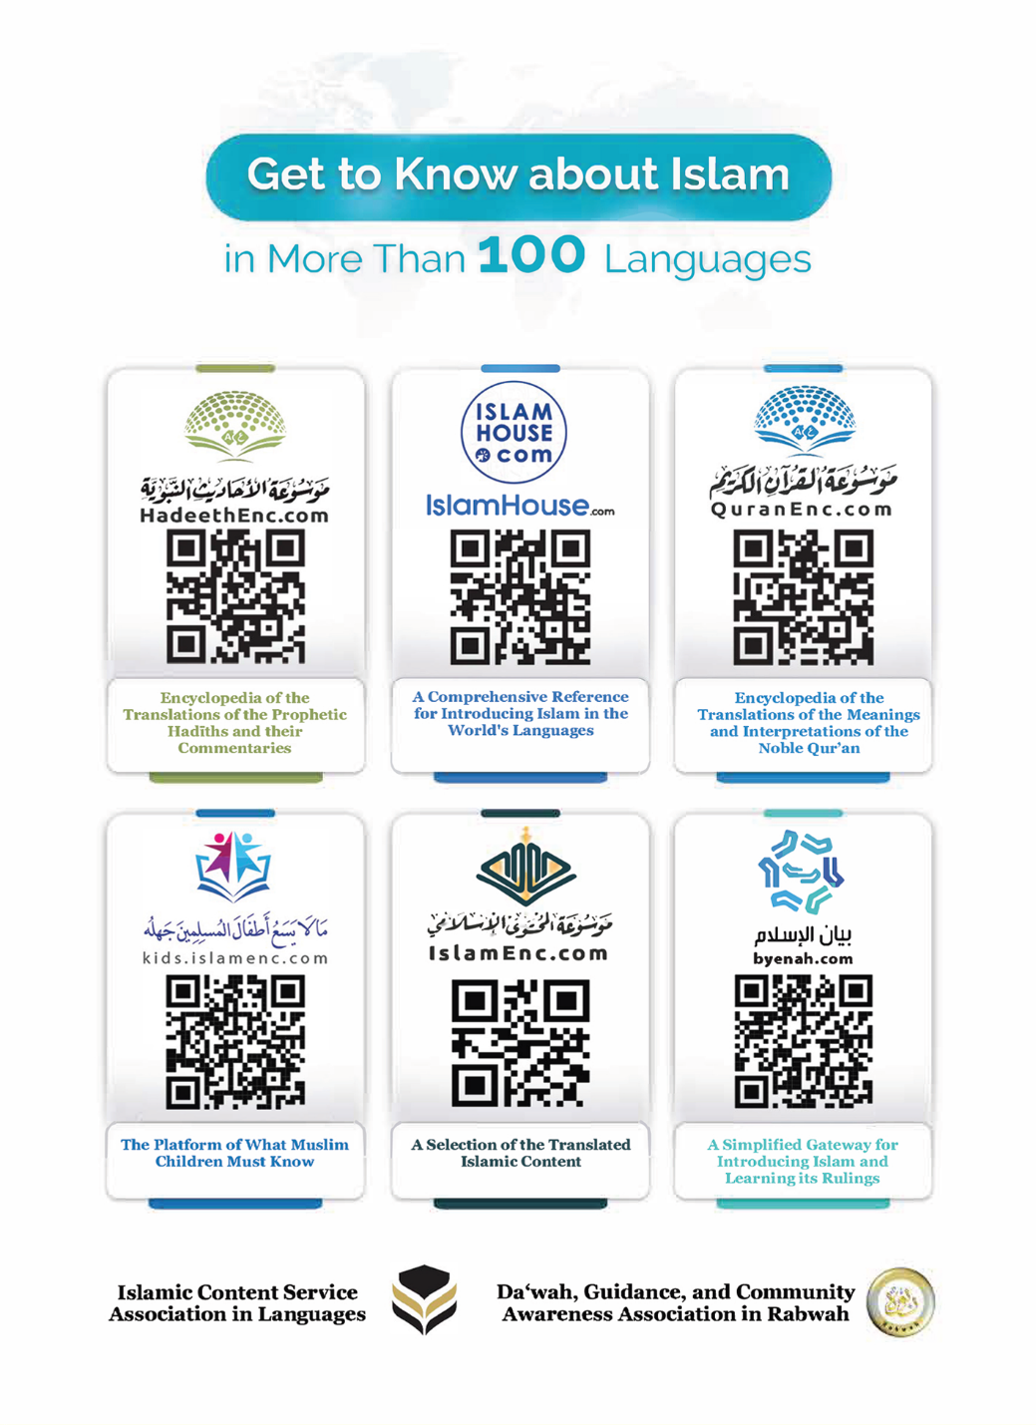
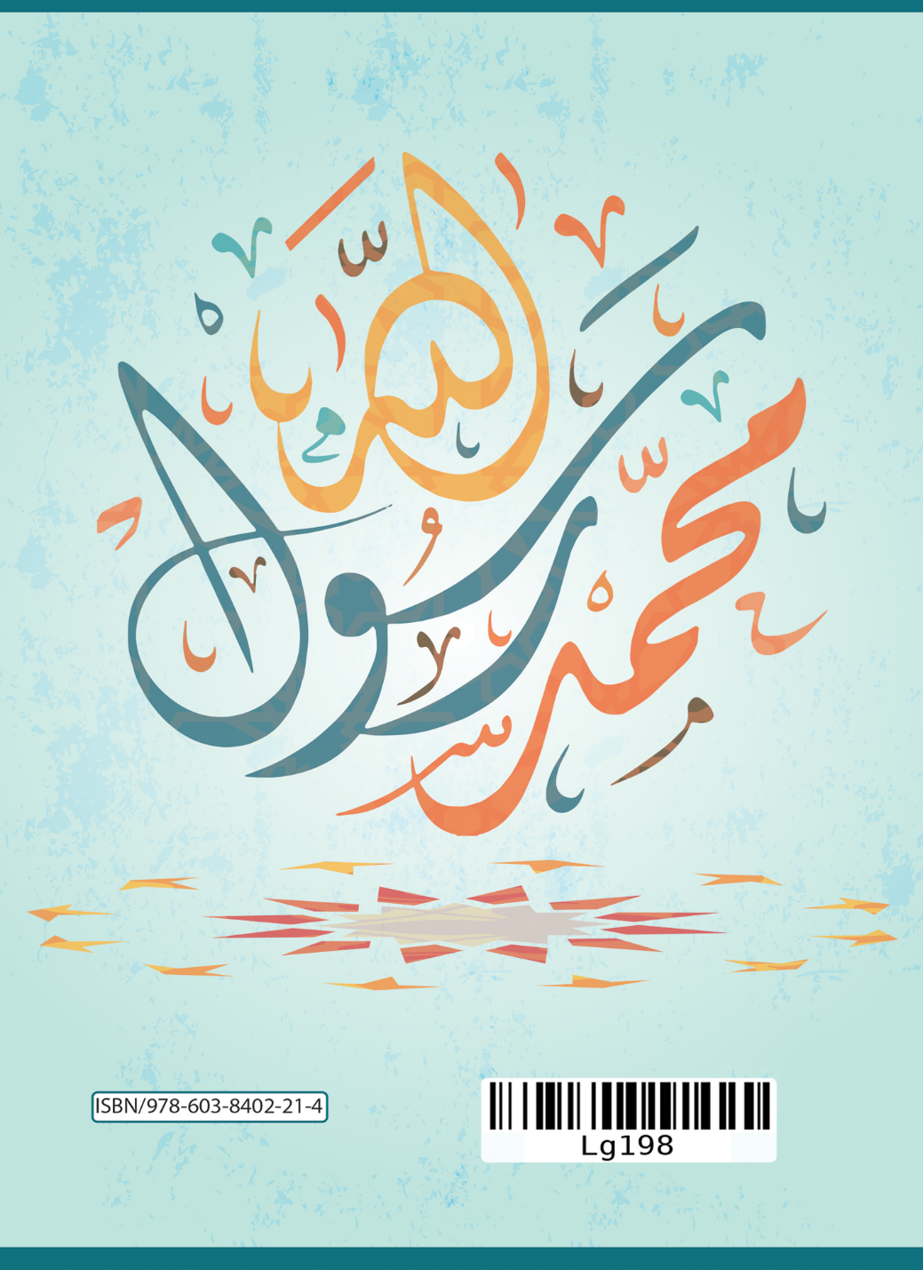

nfubye ebbanga lyonna okuliraaniganya wakati w'ebigambo Omubaka Muhammad olw'okulondoola okuvvuunula era ekyo kyegenderezebwe.
hadith) yegattibwako, okuva mu Hadith ya Aaisha -Allah Amusiime-, Swahiih al-Bukhari (2) 1/7, ne Swahiih Muslim (152) 1/139.
Swahiih Muslim (901)
Swahiih Al-Bukhari 6/15 (4461)

